ABC NEWS/WASHINGTON POST POLL: Ebola
EMBARGOED FOR RELEASE AFTER 7 a.m. Tuesday, Oct. 14, 2014

Amid Broad Worries of an Ebola Outbreak,
Two-Thirds Say the Gov’t Should Do More

Nearly two-thirds of Americans are concerned about a widespread epidemic of the Ebola virus in the United States, and about as many in a new ABC News/Washington Post poll say the federal government is not doing enough to prevent it.

Indeed, more than four in 10 – 43 percent – are worried that they or an immediate family member might catch the disease. That’s similar to the level of concern about other viral outbreaks in some previous ABC/Post polls – but more consequential, given Ebola’s high mortality rate.

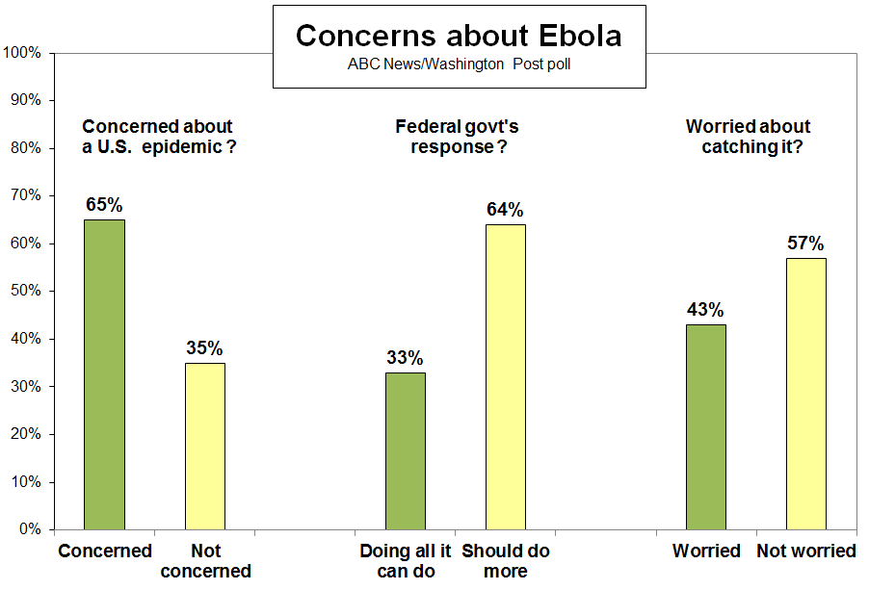

Despite these concerns, more than six in 10 are at least somewhat confident in the ability of both the federal government, and their local hospitals and health agencies, to respond effectively to an outbreak. Future views remain to be seen; most interviews in this poll were done before the news Sunday morning that a nurse who treated an Ebola patient in Dallas had herself become infected. (Results of interviews conducted Sunday were essentially the same as on previous nights.)

In terms of preventive actions, the poll, produced for ABC by Langer Research Associates, finds near-unanimous support (91 percent) for stricter screening of incoming passengers from Ebola-affected countries in Africa. Two-thirds support restricting entry of such individuals into the United States.

The Ebola outbreak has killed more than 4,000 people, mainly in the West African countries of Guinea, Liberia and Sierra Leone, raising broad concerns about its rapid spread there and the risk globally. Margaret Chan, head of the World Health Organization, on Monday called it “the most severe acute public health emergency in modern times.” In five U.S. airports, the federal government is beginning to screen arriving passengers whose travel originated from the three most-affected countries.

Barack Obama, for his part, gets essentially an even split in his handling of the federal response to the Ebola outbreak: Forty-one percent of Americans approve and 43 percent disapprove, with typical partisan and ideological divisions.

WHO’S WORRIED – Worries about catching Ebola are 13 percentage points more prevalent among women than men (49 vs. 36 percent), but the biggest differences are by education, income and race. Among people who have a postgraduate degree, just 20 percent are worried that they or an immediate family member might catch the Ebola virus. That rises to 32 percent of those with an undergraduate degree and to 50 percent among all those who lack a college degree – peaking at 62 percent of those who don’t have a high school diploma.

By income, worry ranges from 19 percent of those in the $100,000-plus bracket to 51 percent in less-than-$50,000 households, including 58 percent of those with incomes less than $20,000 a year. And by race, worry about catching Ebola is 21 points higher among nonwhites than whites, 57 vs. 36 percent. Indeed, a third of nonwhites, 32 percent, are “very” worried about becoming infected, compared with fewer than half as many whites, 14 percent.

Catching the Ebola virus
Worried Not worried
All 43% 57

Men 36 64
Women 49 50

Less than high school 62 38
High school graduate 55 44
Some college 40 60
College graduate 32 68
Post-graduate 20 79

Less than $20K 58 42
$20-$50K 46 54
$50-$100K 43 57
$100k+ 19 81

Whites 36 64
Nonwhites 57 43

These gaps may reflect differences in information about Ebola, different levels of confidence in the quality of health care available to each group, or some of both.

VIEWS of GOVERNMENT – There’s also a sharp difference by a combination of partisanship and ideology: While 27 percent of liberal Democrats worry about catching the virus, that rises to 44 percent of conservative Republicans. (Each group accounts for about one in seven adults.)

The reason seems clear: Conservative Republicans are vastly less likely than liberal Democrats to express confidence in the federal government’s ability to respond effectively to an outbreak, 48 vs. 84 percent.

Conservative Republicans also are far more apt than liberal Democrats to express concern about the possibility of a widespread outbreak, 73 vs. 45 percent, and to say the United States should be doing more to try to prevent further cases, 77 vs. 40 percent. (Differences also are reflected by partisanship alone and ideology alone. The divisions simply peak among the two most disparate political/ideological groups.)

The difference between these groups is much wider in terms of their confidence in the federal government to respond compared with their confidence in their local hospitals and health agencies. There’s a 36-point gap between liberal Democrats and conservative Republicans on the former, compared with 15 points on the latter.

Liberal Conservative
Democrats Republicans Diff.
U.S. should be doing more 40% 77% 37 pts.
Confident in federal gov’t to respond 84 48 36
Concerned about widespread epidemic 45 73 28
Worried about catching Ebola 27 44 17
Confident in local hospitals to respond 75 60 15

There are group differences on specific actions, as well. Restricting entry by people from affected countries wins less support from young adults vs. those age 30 and older (57 vs. 70 percent), and is less popular with liberals and Democrats compared with others.

COMPARISONS – At 43 percent, worries about catching the Ebola virus are lower than worries about catching the swine flu at their peak in October 2009, but higher than worries about catching the SARS virus in late April 2003. Those concerns fluctuated, and at other times were more similar to worry about Ebola now. In one other comparison, concern about catching the bird flu virus was similar in March 2006 to today’s level on Ebola.

Confidence in the federal government’s ability to handle an outbreak is similar to what it was for bird flu, but lower than it was for swine flu; the same pattern holds for confidence in local hospitals and health agencies.

The difference between those episodes and this one, as noted, is Ebola’s very high mortality rate – but also its lower risk of contagion.

Finally, the public’s sense that the federal government is “doing all it reasonably can do” to try to prevent an outbreak stands in stark contrast to views on a very different sort of public health crisis in a very different time, the anthrax attacks of fall 2001. At that time, in the midst of a post-9/11 rally in support of the federal government, 61 percent said it was doing all it could. As noted, just 33 percent say so now.

METHODOLOGY – This ABC News/Washington Post poll was conducted by telephone Oct. 9-12, 2014, in English and Spanish, among a random national sample of 1,006 adults, including landline and cell-phone-only respondents. Results have a margin of sampling error of 3.5 points, including design effect. Partisan divisions are 31-24-36 percent, Democrats-Republicans-independents.

The survey was produced for ABC News by Langer Research Associates of New York, N.Y., with sampling, data collection and tabulation by Abt-SRBI of New York, N.Y.

Analysis by Gary Langer.

ABC News polls can be found at ABCNEWS.com at http://abcnews.com/pollingunit.

Media contact: Van Scott Jr., (212) 456-7423.

Full results follow.

*in data columns = less than 0.5 percent

1-2f, 3-27a, 34-38 held for release.

2g. (Half sample) Do you approve or disapprove of the way Obama is handling the federal government’s response to the outbreak of the Ebola virus? Do you approve/disapprove strongly or somewhat?

------- Approve ------ ----- Disapprove ----- No
NET Strongly Smwht NET Smwht Strongly opinion
10/12/14 41 19 22 43 13 30 16

27b. On some other issues, how do you feel about the possibility that you or someone in your immediate family might catch the Ebola virus – very worried, somewhat worried, not too worried or not worried at all?

------ Worried ------ ------ Not worried ------- No
NET Very Somewhat NET Not too Not at all opinion
10/12/14 43 20 23 57 27 29 *

Compare to:
10/18/09* 52 21 30 46 26 20 *
8/17/09 39 13 26 61 30 31 *
3/5/06** 41 13 28 59 36 23 *
4/27/03*** 33 11 22 67 34 33 1
4/3/03 38 11 27 62 37 24 3
*The H1N1 virus known as swine flu; 10/18/09 includes 2 percent “already have”
**bird flu
***the SARS virus

28. Apart from you and your family, how concerned are you about the possibility of a widespread Ebola epidemic occurring in the United States – very concerned, somewhat concerned, not so concerned or not concerned at all?

----- Concerned ----- ----- Not concerned ----- No
NET Very Somewhat NET Not so Not at all opinion
10/12/14 65 31 34 35 19 15 *

29. How confident are you in the federal government’s ability to respond effectively to an outbreak of the Ebola virus in the United States – very confident, somewhat confident, not so confident or not confident at all?

----- Confident ----- --- Not confident --- No
NET Very Somewhat NET Not so At all opinion
10/12/14 62 19 43 37 21 16 *

Compare to:
10/18/09* 69 19 50 31 18 12 1
8/17/09 73 23 50 26 18 9 1
3/5/06** 59 16 44 40 25 15 *
*the H1N1 virus known as swine flu
**bird flu

30. How about your local hospitals and health agencies – how confident are you in their ability to respond effectively to an outbreak of the Ebola virus – very confident, somewhat confident, not so confident or not confident at all?

----- Confident ----- --- Not confident --- No
NET Very Somewhat NET Not so At all opinion
10/12/14 63 19 44 35 20 16 2

Compare to:
10/18/09* 79 33 47 20 11 8 1
8/17/09 82 33 48 18 12 5 1
3/5/06** 64 21 42 36 22 13 1
*the H1N1 virus known as swine flu
**bird flu

31. Do you think the United States is doing all it reasonably can do to try to prevent further cases of Ebola in the United States, or do you think it should do more?

Doing all Should No
it can do more opinion
10/12/14 33 64 4

Compare to: Do you think the United States is doing all it reasonably can do to try to prevent further biological attacks like this anthrax situation, or do you think it should do more?

Doing all Should No
it can do more opinion
10/24/01 61 37 3

32. In dealing with the Ebola outbreak, would you support or oppose stricter screening of people entering the United States who have been in African countries affected by the outbreak?

Support Oppose No opinion
10/12/14 91 6 3

33. In dealing with the Ebola outbreak, would you support or oppose restricting entry to the United States by people who’ve been in affected countries?

Support Oppose No opinion
10/12/14 67 29 4

*** END ***

