ABC NEWS/WASHINGTON POST POLL: Trump/2020
EMBARGOED FOR RELEASE AFTER 6 a.m. Monday, April 29, 2019

As in 2018, Health Care Ranks
Among Trump’s 2020 Challenges

The keystone issue of the 2018 midterms may stick around to trouble Donald Trump in 2020: Americans by a 17-point margin say his handling of health care makes them more likely to oppose than to support him for a second term.

That result in the latest ABC News/Washington Post poll marks one of many challenges for Trump as he seeks re-election. The Mueller report and his immigration policies are substantial negatives as well. As reported Friday, his overall popularity is low; just 39 percent approve of his work in office. And 55 percent flatly rule out voting for him next year.

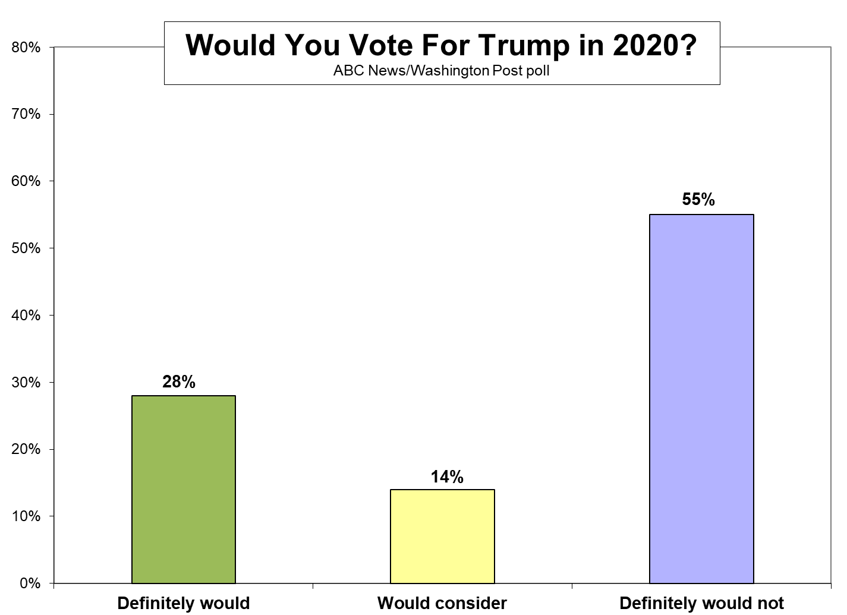

Further, a remarkable 75 percent of Americans, and 85 percent of registered voters, say they’re certain to vote in the 2020 election – intended turnout levels commonly seen in the closing days of a presidential contest. If that intensity is maintained, it may boost the Democrats, many of whose core support groups are less reliable voters.

But even as Trump faces bigger-than-typical risks for a president seeking re-election, 2020 may not be as much of a slam-dunk for the Democrats as some of his ratings would suggest. One example: Among those who rule Trump out, just 29 percent say they’ll definitely support his eventual Democratic opponent. Two thirds, instead, say they’re waiting to see who that is.

Also, while more than half say they’ll definitely not support Trump, 42 percent of Americans overall, and 45 percent of registered voters, say they’d at least consider him for a second term. Trump won 46.1 percent of the vote to Hillary Clinton’s 48.2 percent in 2016, demonstrating that losing the popular vote is irrelevant if you pull a winning hand in the Electoral College.

Willingness to consider Trump varies markedly among groups in this poll, produced for ABC by Langer Research Associates. In the Midwest – the region where he won the presidency – 54 percent say they’d definitely or possibly support him for re-election. So do 54 percent of whites nationally and 58 percent in rural areas where his support is strongest.

His weaknesses are apparent in these results as well: In his own party, 15 percent of Republicans say they definitely will not support Trump for-election, as do 30 percent of conservatives. This soars to 61 percent of 18- to 39-year-olds, 62 percent of women, 64 percent of those with a postgraduate degree, 68 percent of urban residents, 81 percent of Hispanics and 86 percent of blacks.

APPROVAL and ISSUES – Overall approval may be chief among Trump’s challenges. He’s averaged just a 38 percent approval rating since he took office, the lowest by far for any president in his first 2¼ years in office in surveys dating to Harry Truman’s administration more than 70 years ago.

Truman overcame a recession-fueled 40 percent approval rating in June 1948 to win re-election five months later. One difference, though, is that Truman had seen much higher approval scores, averaging 56 percent – 18 percentage points better than Trump – in his first 2¼ years. Trump’s never exceeded 42 percent approval.

Other factors add to the president’s challenges:

- Forty percent say his handling of health care makes them more likely to oppose him for re-election, while 23 percent say it makes them more likely to support him. Voters in the 2018 midterms selected health care as the top issue in their vote by a wide margin over three others offered – and those who picked it favored Democrats for Congress by 75-23 percent. Trump’s response to the salience of the issue is worth watching; he said April 1 that a GOP vote on a health care reform plan would be put off until after the election.

- Based on his handling of immigration policy, 44 percent say they’re more likely to oppose Trump for a second term, vs. 31 percent more likely to support him, a 13-point net negative.

- The Mueller report produces a 22-point net negative score for Trump: Thirty-six percent say it makes them more likely to oppose him for re-election, vs. just 14 percent more likely to support him. As reported Friday, 58 percent think Trump lied to the public about the Mueller investigation.
Trump’s score on handling international trade is closer – Americans by a net 5 points say it makes them more likely to oppose him for re-election – and he has a net 7-point positive score on handling the economy, likely the cornerstone of his re-election campaign.

 | Makes you more likely to…
 | Support Trump | Oppose Trump | Net impact
The Mueller report | 14% | 36 | -22 pts.
Trump’s handling of…
Health care | 23 | 40 | -17
Illegal immigration | 31 | 44 | -13
International trade | 31 | 36 | -5
The economy | 39 | 32 | +7

To be sure, those who say they’re more likely to oppose Trump on any of these issues generally look like those who are less apt to support him in any case. Nonetheless, the differential net impacts are revealing in terms of his relative strengths and weaknesses.

ALIENATION – Another result marks the extent of public alienation from the political and economic system. Seventy-two percent of Americans say the country’s political system works mainly to benefit those in power; 62 percent say the same about the economic system. Large numbers, in each case, hold that opinion strongly.

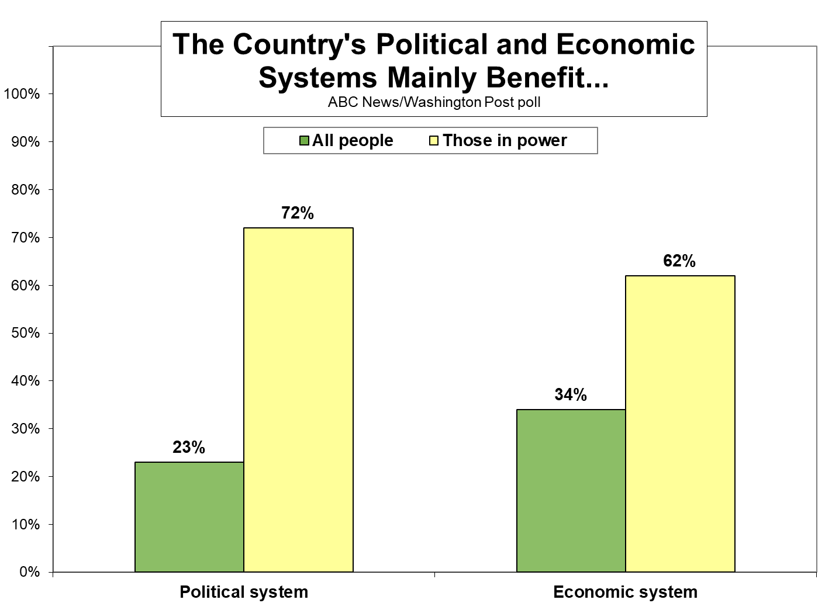

It’s a sentiment that Trump may have harnessed to help him win the White House, but that’s working against him now that he’s in power. Trump has a 63 percent approval rating among those who say the political system benefits all people, and 68 percent approval among those who say all benefit from the economic system. But among the sizable majorities who say these systems mainly benefit the powerful, his approval ratings dive to 31 and 23 percent, respectively.

There’s a similar effect in terms of willingness to consider Trump for a second term. Among those who say all people benefit from the country’s political systems, one-third say they definitely won’t vote for Trump; so do one-quarter of those who say all benefit from the economic system. But among those who say these systems benefit the powerful, 64 and 73 percent, respectively, say they definitely will not support Trump for re-election.

 | The political system benefits… |  | The economic system benefits…
 | All people | Those in power | All people | Those in power
Trump:
Approve | 63% | 31 | 68% | 23
Disapprove | 29 | 64 | 26 | 71
Trump in 2020:
Definitely will/will consider | 63 | 34 | 71 | 25
Definitely not | 32 | 64 | 25 | 73

VOTE INTENTION – Vote intention also is revealing. Virtually as many blacks as whites say they’ll definitely vote in the general election, 77 vs. 80 percent; this falls to 60 percent among Hispanics, who also are less apt to be registered to vote. And it’s 6 points higher among women than men, 78 vs. 72 percent – a slight but potentially important difference, since women are much more critical of Trump.

While blacks and women help the Democrats, the tables turn by age. Turnout intention is substantially lower among younger adults, a more Democratic-oriented group – 66 percent among 18- to 29-year-olds and 71 percent among those 30-39, vs. 79 percent among those 40+. As with Hispanics, this difference is exacerbated by the fact that young adults also are less likely to register to vote in the first place; 73 percent of those under age 40 report being registered, compared with 88 percent of those 40 and older.

Intention to vote rises both with education and income, which are related; it’s 63 percent among people with less than $50,000 in household incomes, but 82 percent in the $50,000-$100,000 range and 91 percent among $100,000-plus earners. It also goes from 70 percent among those who haven’t been graduated from college to 87 percent among college graduates.

Lastly, saying you’ll definitely vote on Nov. 3, 2020, is essentially equal among Democrats and Republicans, at 83 and 85 percent, respectively. That drops to 67 percent among independents, who hold the distinction of often being the key swing voter group in national elections – yet also the hardest to engage.

METHODOLOGY – This ABC News/Washington Post poll was conducted by landline and cellular telephone April 22-25, 2019, in English and Spanish, among a random national sample of 1,001 adults. Results have a margin of sampling error of 3.5 points, including the design effect. Partisan divisions are 29-26-36 percent, Democrats-Republicans-independents.

The survey was produced for ABC News by Langer Research Associates of New York, N.Y., with sampling and data collection by Abt Associates of Rockville, Md. See details on the survey’s methodology here.

Analysis by Gary Langer.

ABC News polls can be found at ABCNEWS.com at http://abcnews.com/pollingunit. Join our mailing list to get updates on all new poll releases.

Media contacts: Heather Riley or Julie Townsend.

Full results follow.

*= less than 0.5 percent

1, 7-14, 19-22 previously released. 2-6 held for release.

16. Assuming Trump is the Republican candidate for president in 2020, would you definitely vote for him, would you consider voting for him, or would you definitely not vote for him?

Definitely Would Definitely No
would consider would not opinion
4/25/19 28 14 55 3
1/24/19 28 14 56 1

17. (ASK IF DEFINITELY NOT VOTE FOR TRUMP) Will you definitely vote for the Democratic candidate for president, will you definitely not vote for the Democratic candidate, or are you waiting to see who that is?

Definitely vote for Definitely not vote for Waiting No
Democratic candidate Democratic candidate to see opinion
4/25/19 29 3 66 2

18. Does Trump's handling of [ITEM] make you more likely to support him for reelection in 2020, more likely to oppose him for reelection, or is it not a factor in your vote?

Summary Table - 4/25/19
More likely More likely Not a No
to support to oppose factor opinion
a. illegal immigration 31 44 24 1
b. international trade 31 36 29 4
c. health care 23 40 33 5
d. the economy 39 32 25 4

19. Do the findings of the Mueller investigation make you more likely to support Trump for reelection in 2020, more likely to oppose him for reelection, or are they not a factor in your vote?

More likely More likely Not a No
to support to oppose factor opinion
4/25/19 14 36 46 3

Compare to:
Do the findings of Mueller’s investigation make you (more likely) to vote for Trump in next year’s presidential election, (less likely) to vote for Trump, or do they make no difference in your vote?

More likely to Less likely to Makes no No
vote for Trump vote for Trump difference opinion
3/29/19* 17 30 51 2
*Post-Schar School

23. Do you think [ITEM] in this country mainly works to benefit (all people) or mainly works to benefit (those in power)? Do you feel that way strongly or somewhat?

Summary table - 4/25/19

---Benefit all people---- -Benefit those in power-- No
NET Strongly Somewhat NET Somewhat Strongly opinion
a. the political
system 23 13 11 72 16 56 4
b. the economic
system 34 23 10 62 13 49 5

*** END ***

