Weekly Data Report  Embargoed for release:  9:45 a.m. Thursday,  Feb. 18, 2021  This  week’s  CCI  45.8 | A sharp decline in economic pessimism amid progress in curbing the coronavirus pandemic produced the best monthly measure of Americans’ expectations for the economy’s direction since before the pandemic began.  Current assessments of personal finances also struck a positive note in this week’s Bloomberg survey, posting their largest four-week advance since September and lifting the overall Bloomberg Consumer Comfort Index to a 2021 high.  On expectations, 33 percent of Americans say the national economy is getting worse, down from 45 percent in January to the fewest since a year ago. A similar share, 30 percent, think the economy is getting better, up 11 percentage points in two months to a one-year high. (The rest, 37 percent, say it’s staying the same.)  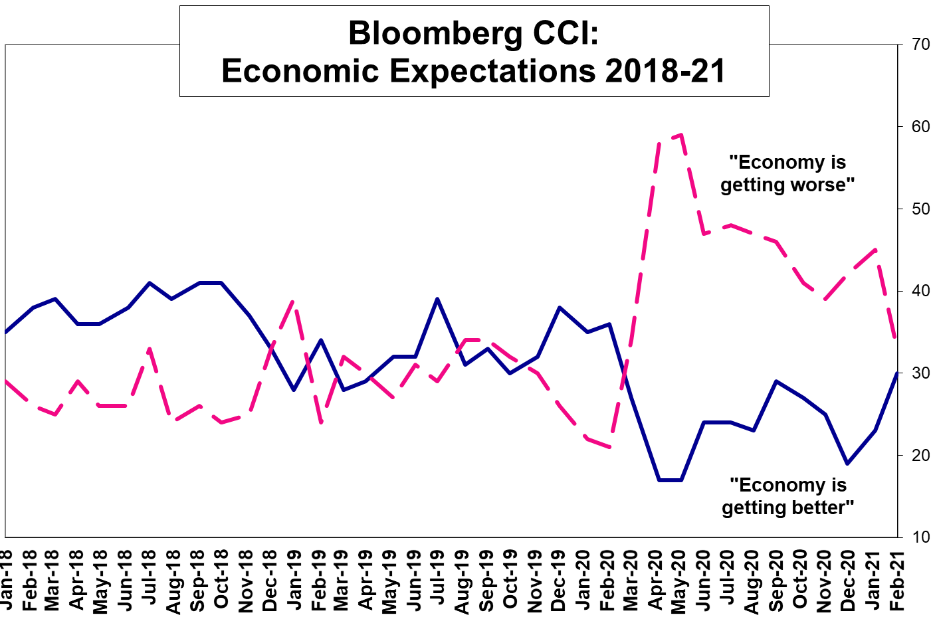  These shifts bring the better-worse margin to -3 points, down from a deeply negative -22 points last month and -42 points in May to its best, again, since last February. It compares with an average -21-point margin since the pandemic began and a long-term average of -17 points in data since March 1986.  In present-day economic views, Americans’ ratings of their personal finances are up 5.2 points in a month to 60.8 on a 0-100 scale, a 2021 high. The gains partially reverse a 9.6-point tumble the two months prior, lifting the overall CCI to an eight-week high, 45.8.  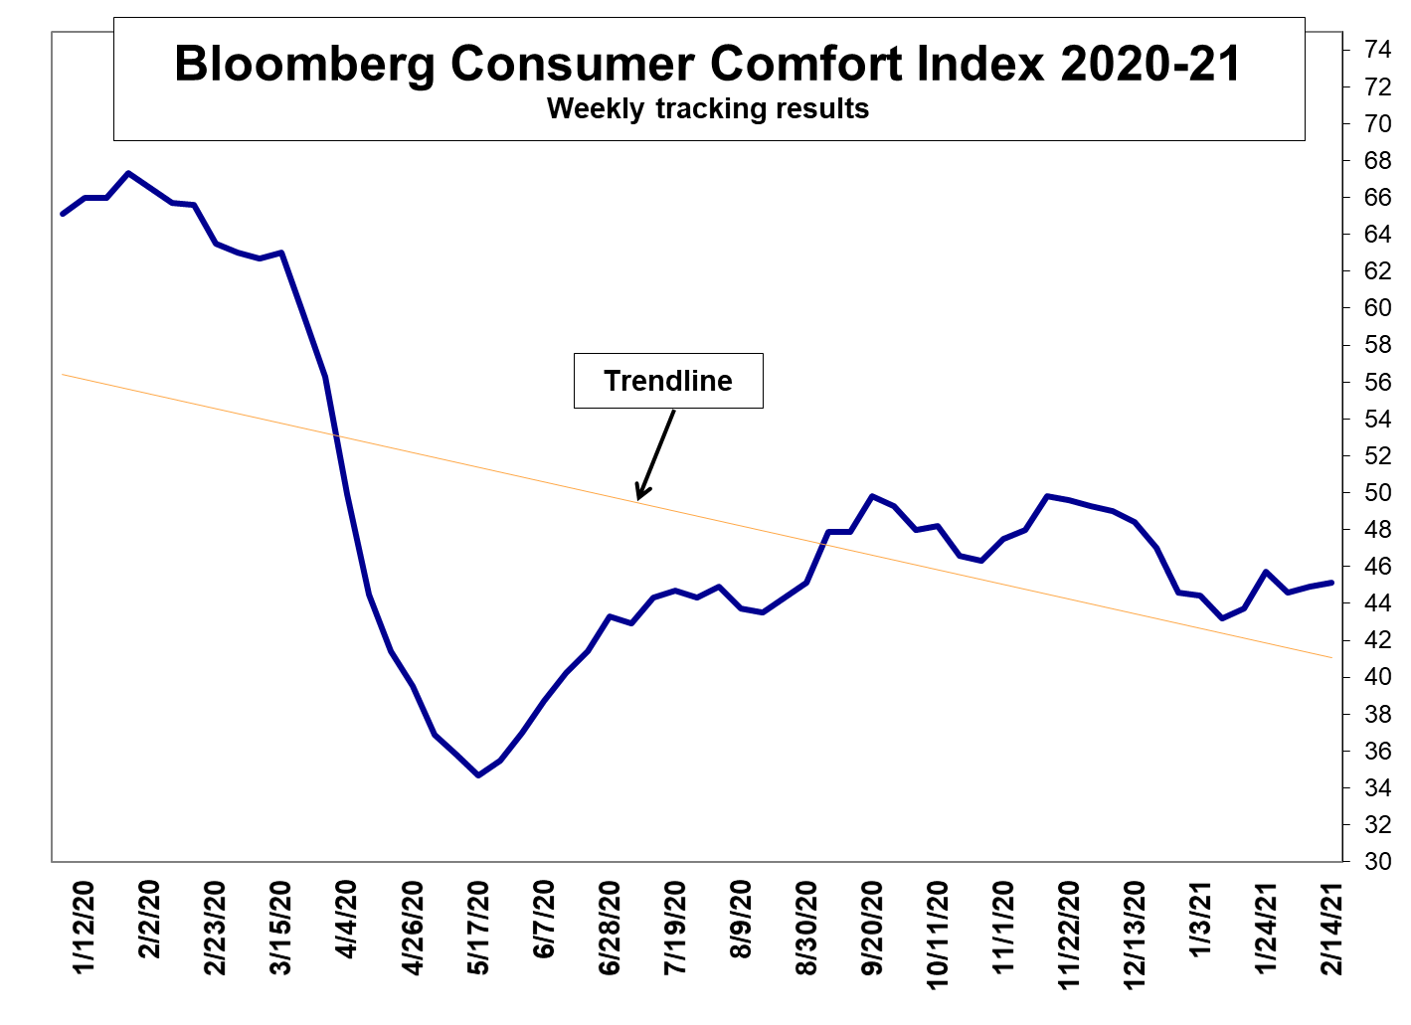  While up, the index, produced by Langer Research Associates, is still on the mend from a mid-November to mid-January tumble that set it back 6.6 points – part of a longer, uneven recovery from its historic descent at the onset of the pandemic. It remains 17.2 points short of its pre-pandemic level and 21.5 points off its two-decade peak about a year ago, having recovered less than half its total losses thus far.  Each CCI gauge is similarly far from a full recovery almost a year into the pandemic:  - The personal finances index is 10.4 points short of its all-time high in early 2020 and 7.8 points off its mid-March level. It’s regained about half its total pandemic losses since bottoming out in mid-May.  - The national economy subindex, steady at 36.1, is a vast 35.2 points off its 19-year high roughly a year ago. It’s up just 13.6 points from its pandemic low, roughly a third of its total losses.  - At 40.4, the buying climate subindex is in its third week without a significant shift, 12.9 points short of its pre-pandemic level and 19.0 points off its record high in late January last year. Without clear trend since September, the subindex is up 11.6 points from its pandemic low, just under half its losses.  The separate economic expectations gauge often has a partisan nature, given that expectations depend on approval or disapproval of the president as the nation’s economic steward. And indeed the outlook among Democrats turned optimistic in the latest survey for the first time since January 2017, +18 points, better-worse. Expectations among Republicans, while improved, remain acutely pessimistic, by a -28-point margin.  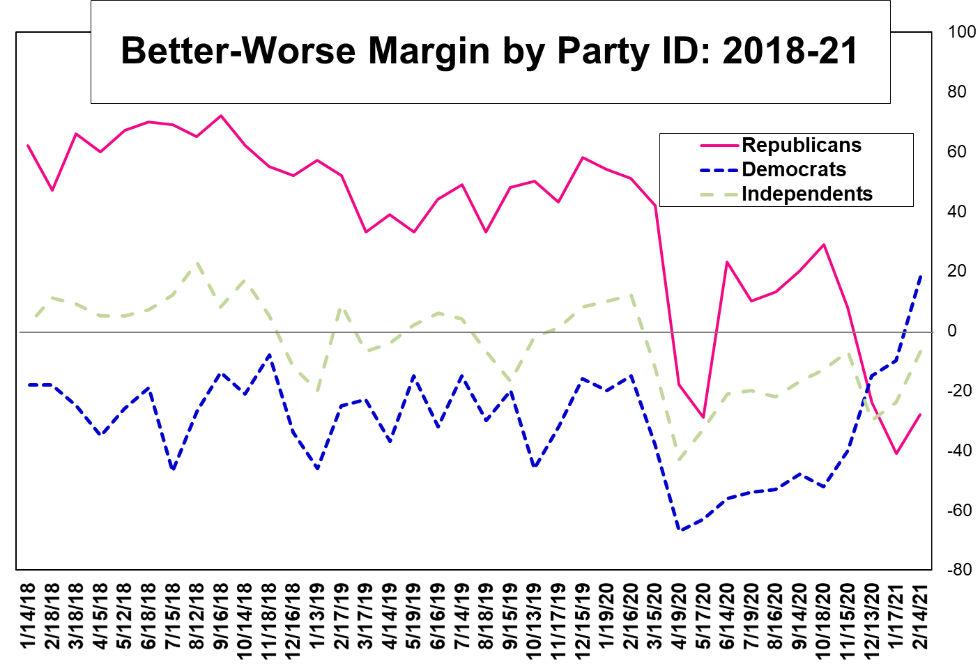  Partisan shifts also are reflected in the current-sentiment CCI. The index among Democrats, 47.2, is its best since late March, up 7.3 points in five weeks. Among Republicans, at 52.6, the index is near its seven-month low two weeks ago. It’s 40.2 among independents, down 5.1 points in three weeks to a three-month low.  Among other groups, the CCI among women is up 5.1 points in five weeks to a two-month high of 45.3 – primarily due to an 8.6-point increase in personal finance ratings the past month. The index among men is down 3.6 points in three weeks to 46.2, narrowing the gender gap to just 0.9 points, its smallest since March 2017.  The index also is at a two-month high, 59.9, among Americans with household incomes of $50,000 or more a year, again chiefly because of improved personal finance ratings the past four weeks. That compares with 33.2 among those with lower incomes, with virtually no improvement since July.
Data summary for 2/18/21

This week 45.8
Last week 44.9
2021 high 45.8 Feb. 14
2021 low 43.2 Jan. 10
2021 average 44.6
2009 average 26.0 Worst full year
2000 average 64.5 Best full year
June 21, 2009 23 Record low (also three other dates in 2008-09)
Jan. 16, 2000 69 Record high
Average since 12/85 43.2

Individual measures:
Average Average
Positive ratings of: This week Last week 2021 ’85-’21
National economy 36% 35 36 36
Personal finances 61 60 58 56
Buying climate 40 40 40 37

Excel Not so
Full ratings of: -lent Good Good Poor
National economy 4% 32 44 20
Personal finances 8 53 31 8
Buying climate 4 37 44 16

Positive High Positive Low
Economy 80% Jan. 16, 2000 4% Feb. 8, 2009
Finances 71% latest Feb. 16, 2020 39% June 21 and 28, 2009
Buying climate 59% latest Jan. 26, 2020 18% latest Oct. 19, 2008

Economy’s direction:
Better Worse Same Better-worse diff.
2/14/21 30 33 37 - 3 pts.
1/17/21 23 45 33 -22
12/13/20 19 42 39 -23
11/15/20 25 39 36 -14
10/18/20 27 41 32 -14
9/14/20 29 46 25 -17
8/16/20 23 47 30 -24
7/19/20 24 48 29 -24
6/14/20 24 47 28 -23

Methodology: The Bloomberg Consumer Comfort Index is produced by Langer Research Associates. Results are based on 1,000 national random-sample landline and cellular telephone interviews, 250 per week in a four-week rolling average. The index, produced weekly since December 1985, is derived by averaging positive responses to each subindex question. Results of each question have a 3.5-point error margin. The expectations question was asked of 500 respondents Feb. 2-14, 2021; that result has a 4.5-point error margin. Fieldwork and tabulation by SSRS of Glen Mills, PA.
02/14/21 This Last 4 Wks 3 Mo. 1 Yr. 12 Mo 12 Mo 12 Mo
Week Week Ago Ago Ago High Low Avg
----- ----- ----- ----- ----- ----- ----- -----
GENERAL POPULATION:
Overall Index 45.8 44.9 43.7 49.8 65.6 65.6 34.7 46.8
State of Economy 36.1 34.8 36.3 40.7 70.7 70.7 22.5 38.8
Personal Finances 60.8 60.1 55.6 65.2 70.5 70.5 52.8 61.0
Buying Climate 40.4 39.9 39.2 43.5 55.6 55.6 28.8 40.5
-------------------------------------------------------------------
OVERALL INDEX BY DEMOGRAPHIC GROUPS
Sex:
Men 46.2 46.3 46.6 53.2 72.0 72.0 40.2 51.2
Women 45.3 43.7 40.9 46.5 59.7 59.7 28.3 42.7
Age:
18 – 34 47.6 49.8 48.6 50.1 64.2 64.2 35.9 47.4
35 – 44 49.8 44.5 41.8 43.8 64.7 65.1 31.8 46.7
45 – 54 48.0 46.6 44.5 54.9 69.1 72.6 34.1 46.8
55 – 64 45.4 43.4 40.8 49.7 63.3 66.0 31.2 44.9
65+ 39.6 39.5 40.0 48.8 67.5 67.5 35.6 47.2
Income:
Under $15K 19.1 17.7 24.7 20.5 34.1 39.4 16.5 25.2
$15K To $24.9K 25.7 19.4 17.0 27.2 40.7 45.0 17.0 30.0
$25K To $39.9K 35.1 34.6 33.2 44.9 53.6 54.6 27.7 40.1
$40K To $49.9K 45.6 53.3 51.4 49.4 63.1 64.1 29.1 47.6
Under $50K 33.2 32.3 32.8 38.2 49.0 51.6 27.6 36.8
Over $50K 59.9 57.1 54.8 61.2 80.6 80.6 43.3 56.9
$50K To $74.9K 57.0 52.4 46.9 57.8 77.3 77.3 39.3 51.9
$75K To $99.9K 59.2 57.1 59.9 61.2 79.1 79.1 36.7 55.8
Over $100K 62.5 61.6 60.7 65.2 83.7 84.5 49.1 62.7
Region:
Northeast 44.5 42.3 38.4 49.5 62.3 62.3 30.3 43.5
Midwest 46.1 47.2 44.9 52.2 67.8 67.8 38.9 48.8
South 47.6 45.5 45.6 49.1 65.8 66.5 34.4 47.9
West 43.5 44.0 43.5 49.1 65.9 65.9 34.3 45.6
Race:
White 49.2 48.2 46.2 52.5 70.8 70.8 37.3 50.3
Black 34.1 34.6 34.1 33.2 43.9 44.8 20.2 33.1
Politics:
Republican 52.6 51.3 52.5 65.2 79.6 83.1 45.3 61.3
Democrat 47.2 43.7 41.2 41.3 57.4 57.4 27.7 39.9
Independent 40.2 44.0 41.9 47.8 65.9 65.9 33.8 44.0
Education:
< High School 24.5 24.3 21.7 25.8 43.7 43.7 17.9 28.8
High Sch. Grad. 35.1 35.1 33.1 47.6 62.3 62.3 31.8 42.6
College + 53.8 52.5 51.6 54.1 70.6 70.6 37.0 51.1
Home:
Own 51.9 49.8 47.4 56.0 72.8 72.8 35.6 51.7
Rent 36.8 37.8 36.8 38.7 52.7 52.7 29.2 38.2
Marital Status:
Single 42.1 44.3 44.8 45.3 60.9 60.9 33.3 43.6
Married 50.7 48.1 46.4 57.0 73.2 73.2 35.9 51.5
Sep/Wid/Div 39.2 39.3 34.9 36.1 51.5 52.8 29.7 38.6
Employ. Status:
Full-Time 54.2 55.1 51.6 56.1 73.3 73.3 40.9 53.7
Part-Time 35.1 30.4 41.8 42.4 59.6 59.6 29.1 40.7
Not Employed 36.5 35.0 33.8 43.3 57.9 57.9 29.3 39.8

The Bloomberg Consumer Comfort Index is produced by Langer Research Associates LLC (Langer).CONSUMER COMFORT INDEX ™ is a trademark or service mark of Langer. BLOOMBERG ® is a trademark or service mark of Bloomberg Finance L.P. Bloomberg Finance L.P. and its affiliates (collectively, "Bloomberg") or Bloomberg's licensors own all proprietary right in such mark. Neither Langer nor Bloomberg guarantee the timeliness, accuracy or completeness of any data or information relating to the Bloomberg Consumer Comfort Index. Langer and Bloomberg makes no warranty, express or implied, as to the Bloomberg Consumer Comfort Index or any data or values relating thereto or results to be obtained therefrom, and expressly disclaims all warranties of merchantability and fitness for a particular purpose with respect thereto. To the maximum extent allowed by law, Langer, Bloomberg, their licensors, and their respective employees, contractors, agents, suppliers and vendors shall have no liability or responsibility whatsoever for any injury or damages - whether direct, indirect, consequential, incidental, punitive or otherwise - arising in connection with the Bloomberg Consumer Comfort Index or any data or values relating thereto - whether arising from their negligence or otherwise. Nothing in the Bloomberg Consumer Comfort Index shall constitute or be construed as an offering of financial instruments or as investment advice or investment recommendations (i.e., recommendations as to whether or not to “buy,” “sell,” “hold” or to enter or not to enter into any other transaction involving any specific interest or interests) by Langer, Bloomberg or its affiliates or a recommendation as to an investment or other strategy by Langer, Bloomberg or its affiliates.

