The Bloomberg Consumer Comfort Index: Concurrent and Predictive Validity

Julie E. Phelan
Gary Langer

Langer Research Associates
7 W. 66th St., 6th Floor
New York, NY
(212) 456-2623

Paper presented May 13, 2011, at the annual conference of the American Association for Public Opinion Research. Revisions are possible; please do not cite without permission.

Abstract
This paper presents an overview of our examination of the validity and reliability of the Bloomberg Consumer Comfort Index (CCI). We have assessed consumer sentiment via the CCI continuously for 25 years by asking 250 randomly selected respondents per week to rate the national economy, their personal finances and the buying climate, with results reported in a four-week rolling average. This has resulted in over 325,000 interviews tracking perceptions of current economic conditions since late 1985. In a 2003 paper we compared the weekly CCI with the two prominent monthly surveys of consumer views, the Conference Board Consumer Confidence Index and the University of Michigan Consumer Sentiment Index, finding that all three indices tracked each other closely and correlated significantly with several key economic indicators. This paper updates and extends our examination of the utility of the Bloomberg CCI by providing a more detailed assessment of its validity and reliability, including an examination of whether the index is a leading indicator of several key monthly economic measures (e.g., the Dow Jones Industrial Average, GDP, the unemployment rate and revolving consumer credit).

Introduction
Consumer confidence – a shorthand phrase for public views of economic conditions – is a closely watched and widely discussed economic indicator. Consumer spending accounts for more than two-thirds of economic activity in this country (Bureau of Economic Analysis, undated). To the extent that consumer confidence interacts with consumer behavior, and with other economic factors, it may provide important information as to the economy's current condition and future direction alike.
Policymakers and economists track consumer confidence closely in the apparent belief it serves as a useful economic forecasting tool. Economic analysts and the news media report its ups and downs. The release of confidence numbers is often cited (with and sometimes without supporting evidence) as a force in the movement of the stock markets (e.g., Associated Press, 2002; Chu, 2003; Fuerbringer, 2002; Portniaguina, 2006) and as a major determinant of consumer spending (Heim, 2010; Kwan & Cotsomitis, 2006; Ludvigson, 2004; Romer, 2009) especially during periods of economic volatility (Throop, 1992). Confidence also has a strong political connection; it's virtually axiomatic that presidential approval suffers, and political discontent grows, as consumer confidence deteriorates (Merkle, Langer and Sussman, 2003; Soulas and Langer, 1994).
While the political importance of consumer confidence is widely accepted (expressed in Clinton campaign manager James Carville's famous aphorism in the 1992 presidential campaign, "It's the economy, stupid"), some commentators have questioned the usefulness of measuring and reporting consumer confidence as a purely economic indicator (e.g., Uchitelle, 2002). Confidence surveys also have been criticized on methodological grounds for the types of questions and response categories they use (Dominitz and Manski, 2004).
This paper examines in detail the longest-standing weekly measure of consumer confidence in the United States, the 25-year old Bloomberg Consumer Comfort Index. Our goal is to provide a comprehensive examination of the fundamental reliability and validity of the Bloomberg CCI in order to establish its potential utility as an indicator of current and future economic conditions. To do so, we provide evidence of the Bloomberg CCI’s internal consistency and its convergent, concurrent and predictive validity. This paper serves as an update and extension of Merkle et al. (2003), which provided an extensive comparison of the methodologies employed by the three main confidence indices and compared their performance across several economic and political variables. In this paper, we focus exclusively on the methodological and empirical underpinnings of the Bloomberg CCI.

Methodology
The Bloomberg survey is conducted by telephone each week over a five-day period, from Wednesday through Sunday, as part of the Excel omnibus survey directed by Social Science Research Solutions of Media, Pa. A stratified, single-stage, random-digit-dialing (RDD) sample of landline telephone households is utilized. Three call attempts are made to each sampled number on three different days during the five-day field period. Within each landline household, a single respondent is selected via the most-recent-birthday method, and weighting adjustments are made for selection probabilities (i.e., for number of phone lines and adults in the household). Data are then weighted to five Census variables, region, age, race, sex and education, using an iterative raking procedure.
An independent random sample of approximately 250 respondents is interviewed each week, and results are presented in a four-week rolling average with a total sample size of 1,000. Consumer confidence is assessed with three questions measuring current economic sentiment. Specifically, respondents are asked to separately rate the national economy, the buying climate and their personal finances as excellent, good, not so good or poor.
The CCI value is calculated by subtracting the negative responses to each index question (“not so good” and “poor”) from the positive responses to that question (“excellent” and “good”). The three resulting subindex numbers are then added together and divided by three. The index can range from -100 (all respondents answer negatively on all three questions) to +100 (all respondents answer positively to all three questions). As of February 2011, the Bloomberg CCI is publicly released each Thursday at 9:45 a.m.

Face Validity and Internal Consistency
Consumer confidence typically is defined as a measure of how positively (or negatively) people feel about the overall state of the economy and their personal financial situation. Face validity is simply a question of whether the operationalization of a construct “on the face of it” appears to be valid. While admittedly this is the easiest form of validity to demonstrate, it is nonetheless an important hurdle. As noted, the Bloomberg CCI assesses confidence by asking participants separately to rate the national economy, their personal finances and the overall buying climate as “excellent,” “good,” “not so good” or “poor.” This is a simple and straightforward operationalization of consumer confidence, and there can be little argument that these three questions, at least on the surface, tap precisely what consumer confidence purports to be.
In addition to face validity, an important primary concern is whether a measure is internally consistent. A measure is deemed internally consistent if each of the items that are supposed to reflect the same construct yield similar results. While the three items of the Bloomberg CCI measure different substantive areas (ratings of the economy, finances and the buying climate), they are all proposed to represent the single construct of consumer confidence. To assess whether this is in fact true, we assessed internal consistency in two ways. First, we computed the Cronbach’s alpha for the three items that compose the Bloomberg CCI using weekly aggregate data from December 1985 through March 2011. Cronbach’s alpha assesses the internal reliability of a measure on a scale from 0 to 1, with 1 indicating perfect agreement on all items. It increases as intercorrelations among items increase, but also is impacted by the number of items that make up a scale. All things equal, a scale with a greater number of items will have a higher Cronbach’s alpha. The Cronbach’s alpha for the Bloomberg CCI is .85, which indicates a good degree of internal consistency, especially given that it is only a three-item scale.
We also computed the long-term correlation between the three subindices using the same aggregated weekly data. As previously noted, the subindices are computed by subtracting the percent of ratings that are negative from the percent of ratings that are positive for each of the three items. As can be seen in Table 1, the correlations among the three sub-indices range from .88 to .93, which indicates a high-level of agreement over time. As ratings of the economy improve, so to do ratings of personal finances and the buying climate (and vice-versa).

Table 1
Correlations Among the Three Subindices

Economy Index Finances Index Buying Index
Economy Index --
Finances Index .91** --
Buying Index .93** .88** --
**p < .001. n = 1322 weeks

Convergent Validity
Given face validity and internal consistency, it next is useful to assess the convergent validity of the Bloomberg CCI. Convergent validity is demonstrated when measures that theoretically should be related converge upon the same general result. We assessed the convergent validity of the Bloomberg CCI by comparing and contrasting it with the other two prominent, ongoing indices of consumer confidence in the United States, the 65-year-old University of Michigan survey and the 44-year-old survey from The Conference Board.
The Bloomberg CCI and the Conference Board and Michigan consumer confidence indices all purport to assess the construct “consumer confidence.” However, Michigan and Conference Board measure this construct in ways that differ from the Bloomberg CCI. First and foremost, the Bloomberg CCI is released weekly, whereas the Conference Board and Michigan indices are released monthly, with preliminary estimates available earlier in the month. The Bloomberg and Michigan indices both utilize RDD telephone interviews with random in-house selection, while until February 2011 the Conference Board index was based on a mail-in survey with respondent selection via a non-random panel. At that point, the Conference Board index switched to a random probability mail sample, but only revised data back to November 2010, raising some question about continuity of trend.
The operationalization of “consumer confidence” differs from survey to survey, with different questions used to tap confidence (see Appendix A for full question wording). The Michigan and Conference Board indices also include economic expectations in their overall measure of consumer confidence (in addition to releasing separate current condition and expectations indices) while the Bloomberg index keeps expectations as a completely separate measure. For a full review of the methodological differences between these three confidence measures see Merkle et al. (2003).
Despite their operational differences, these measures should be related because they all seek to assess the same basic construct. Merkle et al. (2003) found that a monthly version of the Bloomberg CCI correlated at .88 and .90 with the full Michigan and Conference Board indices, respectively, and at .83 and .93 with their current conditions subindices. We find similar strong relationships today. The updated correlations among the three indices can be seen in Table 2.
Table 2
Correlations Among Confidence Indices

CCI MI Full CB Full MI Curr.
Bloomberg CCI --
Michigan Full .89** --
Conf. Board Full .93** .90** --
Michigan Current .84** .94** .88** --
Conf. Board Current .92** .80** .96** .80**
*p < .001; n = 303

As in Merkle et al. (2003), our analysis used the final monthly results of the Michigan and Conference Board index, and the last release of the month for the Bloomberg CCI, which included data from the preceding four weeks. The time period under investigation was between December 1985 (when the Bloomberg CCI began) and March 2011, a total of 303 months. As can be seen, the three consumer confidence measures continue to track closely with one another – none of the correlations reported in the 2003 paper have attenuated. Thus, despite major methodological differences the Bloomberg CCI and the other two major measures of consumer confidence converge as expected, suggesting they all tap the same underlying construct.

Known-Groups Validity
We next assessed the Bloomberg CCI’s “known groups” validity, by testing whether results from the CCI distinguish among groups that would be expected to differ in their economic views. Specifically, we examined the long-term averages of the CCI among various demographic groups, with the expectation that consumer confidence would be higher among more affluent groups and lower among those who are less well-off financially.
As can be seen in Table 3, the Bloomberg CCI does distinguish between groups in the expected pattern. Consumer confidence is higher among men (who are more likely to be employed, and employed at higher-paying jobs) than women, t(249) = 35.78, p < .001, d = .68. Consumer confidence increases with yearly income, and each income category is significantly different from the next, all ts > 9.2, ps < .001, ds > .54. Consumer confidence is higher among whites (who tend to have higher yearly incomes) than blacks, t(249) = 33.83, p < .001, d = 1.15. It is also higher among Republicans, who likewise tend to have higher incomes, than it is among Democrats and independents, ts > 22.80, ps < .001, ds > .98. The Bloomberg CCI is higher among those who have a college degree than those who have only a high school diploma, t(249) = 42.21, p < .001, d = .83; higher among those who own their home than those who rent, t(249) = 41.88, p < .001, d = .91; and higher among those who have a full-time job than those who have a part-time job or no job at all, ts > 24.75, ps < .001, ds > .54. In addition to being statistically significant, most of these comparisons have a Cohen’s d of .8 or greater, which is considered a large effect (Cohen, 1988), and all comparisons have a Cohen’s d of at least .5, which is considered a moderate effect. Thus, the Bloomberg CCI statistically distinguishes among known groups, with differences that are meaningfully large.

Table 3
A Demographic Comparison of the Bloomberg CCI

Long-term average
Men - 6.5
Women -22.6

Income: <$15K -51.5
Income: $15-25K -36.0
Income: $25-40K -20.3
Income: $50K+ +14.1
Income: $50-75K* -18.7
Income: $75-100K* - 6.2
Income: $100K+* +12.6

Race: White -11.3
Race: Black -37.5

Republicans + 5.5
Democrats -24.8
Independents -18.9

Education: H.S. -21.0
Education: College+ - 1.0

Home: Own - 8.9
Home: Rent -30.2

Employed: Full-time - 5.5
Employed: Part-time -18.6
Employed: Not at all -25.7
*Note: Income breaks >$50,000 were included
beginning in January 2005 (n = 75)

Concurrent and Predictive Validity
A measure is maximally useful when it can reliably explain or predict other indicators or behavior. Thus the most important type of validity in data such as the Bloomberg CCI is its concurrent and predictive validity – that is, how well it relates to or can predict some criterion measure. We therefore examined the extent to which the Bloomberg CCI correlates with objective economic measures and can anticipate changes in some of these measures.
Merkle et al. (2003) provided a first look at the concurrent validity of the Bloomberg CCI and the Michigan and Conference Board indices by assessing their correlation with eight major economic measures. Since the focus of this paper is a comprehensive examination of the validity of the Bloomberg CCI in particular, we focus only on its correlations with an expanded set of economic indicators. We also extend Merkle et al. (2003) by using data through March 2011 and by conducting lagged correlations in order to provide preliminary evidence of the predictive validity of the Bloomberg CCI vis-à-vis the other indicators analyzed.
The indicators we selected for analysis can be roughly broken up into six main topic areas assessing general economic conditions, employment, real estate, personal finances, retail and manufacturing and the political environment (see Table 4 for a list of economic indicators by subject area and how frequently the indicator is released, and Appendix B for definitions). Weekly indicators were compared with the weekly CCI, monthly indicators were compared to the final release of the CCI each month (which includes the prior four weeks worth of data) and the quarterly indicator (GDP) and bi-annual indicator (congressional re-election rate) were compared to quarterly and annual averages of the CCI, respectively.
Table 4
Economic Indicators by Topic Area

Frequency Total N
General economy
Dow Jones Industrial Average (Dow) monthly 304
Gross Domestic Product (GDP) quarterly 101
Prime rate monthly 304

Employment
Average unemployment duration monthly 304
Total non-farm employment monthly 304
Underemployment rate (U6 rate) monthly 207
Unemployment rate monthly 304
Initial unemployment insurance claims weekly 1321
Continuing unemployment insurance claims weekly 1321

Real estate
Case-Schiller composite 20 monthly 123
Housing starts monthly 304
NAHB housing market index monthly 304
New home sales monthly 304
Residential construction spending monthly 219

Personal finances
Personal income monthly 303
Personal savings rate monthly 304
Revolving credit monthly 303

Retail and manufacturing
Average U.S. gasoline prices weekly 1077
Capacity utilization monthly 304
Consumer price index (CPI) monthly 304
Durable goods orders monthly 120
Industrial production index monthly 304
Retail sales monthly 231

Political environment
Presidential approval monthly 296
Congressional re-election rate bi-annual 13

Prior to assessing the relationships between the CCI and the economic and political indicators, however, it was important to deal with the fact that many of the economic measures are strongly correlated with time (see Table 5). Many economic measures, especially those that are measured in dollars or reflect population sizes, have a strong time trend that has little to do with economic conditions. For example, the Dow, personal income and the price of gasoline all have steadily risen since 1985. Ten of the economic indicators examined in this paper correlate with time at .84 or greater. Three additional indicators (initial and continuing unemployment claims and residential construction spending) also significantly correlate with time, though less strongly (as theoretically expected given population growth and inflation). On the other hand, the CCI moves independently of time, rising when economic conditions are improving and decreasing when economic conditions are declining. Therefore, a simple correlation between the CCI and any measure with a strong time trend may underrepresent the true relationship between variables.
Table 5
Correlation Between Time
and Economic Measures
Time
CPI 1.00**
GDP (n=100) .99**
Personal expenditures (n=303) .99**
Income (n=303) .99**
Retail sales (n=231) .98**
Revolving credit (n=303) .98**
Nonfarm employees .94**
Industrial production .93**
Dow monthly close .92**
Gas prices (n=1,078) .84**
Continued unemployment claims .52**
Residential construction spending .47**
Initial unemployment claims .29**
**p<.001; n=304 except where noted.

There are a number of ways to deal with economic variables that rise with time independently of economic conditions. Our interest was in determining whether the economic indicators were higher or lower than would be expected simply based on their time trend, and more specifically, whether the CCI moved in line with these fluctuations, and might anticipate them. To investigate this, we de-trended all of the economic data that rise with time (all variables shown in Table 5) using regression analyses. For each time-trended economic indicator, we computed a regression with time entered as the predictor. We then saved the residuals (i.e., the variance in the variable that was not attributable to time), and correlated those with the CCI. In other words, we removed the variance in each indicator that was simply due to the passage of time, and used these detrended variables for the subsequent analyses. We did not transform variables that do not have a time-trend component (all variables not listed in Table 5).
To assess the concurrent validity of the Bloomberg CCI, we simply correlated the (weekly, monthly, quarterly or annual) Bloomberg CCI with each economic indicator. The first column of Table 6 shows these correlations. All correlations are statistically significant and in the expected direction. Higher consumer confidence is associated with higher Dow monthly closes, a higher GDP and prime rate, greater non-farm employment, more real-estate activity, higher levels of revolving credit and personal income, more manufacturing and retail activity and a more positive political environment (i.e., higher presidential approval and greater congressional re-election rates). On the other hand, lower consumer confidence is associated with higher unemployment and underemployment, greater personal savings (due to decreased spending), and higher prices.
In terms of economic variables, the CCI correlates most strongly with the Dow, the U6 rate (“discouraged” unemployment), non-farm employment, the monthly unemployment rate and industrial production, accounting for more than half of the variance in each of these variables (all r² > .59). The CCI is a moderate correlate of quarterly GDP, initial and continuing unemployment insurance claims, average unemployment duration, the Case-Schiller composite 20 index, the NAHB housing market index, housing starts, new home sales, revolving credit, and the CPI, explaining more than a quarter of the variance in each of these variables (r²s between .28 and .49). Finally the CCI has small but statistically significant correlations with the prime rate, residential construction spending, personal savings rate, personal income, gasoline prices, durable goods orders, capacity utilization, and retail sales, accounting for 7 percent to 25 percent of the variance in these variables. The fact that all relationships are statistically significant, and many have effect sizes in the moderate to large range, provides compelling evidence of the concurrent validity of the CCI.
We also assessed the Bloomberg CCI’s relationship with two political variables – presidential approval and congressional re-election rates. As can be seen in Table 6, both are positively correlated with consumer confidence. The Bloomberg CCI shows a strong positive correlation with congressional re-election rate, such that in years when the economy has been in good shape, members of Congress tend to keep their jobs – whereas when the economy is in bad shape, congressional leaders are more apt to be sent packing. The CCI also shows a modest, but statistically significant, positive correlation with presidential approval. As people become more positive about the economy, they also tend to feel more positively about the president. Both findings support the anecdotal suggestion that, absent a war or national crises, political leaders sink or swim based mostly on the economy.
It is worth noting that the CCI’s correlations with some indicators, while significant overall, are stronger in specific time periods. The correlation between presidential approval and the CCI is particularly strong when economic conditions are worsening and consumer confidence is falling. In the period leading up to the ‘great recession,’ as the CCI fell, so too did President George W. Bush’s job approval rating, with the two correlating at .80 from the end of 2006 through the end of 2008. Likewise, during the 1990-91 recession and its aftermath (from summer 1990 to winter 1992), the correlation between President George H.W. Bush’s job approval rating and the Bloomberg CCI rose to .70. Moreover, as Merkle et al. (2003) noted, the overall correlation between the CCI and presidential approval has been suppressed by overarching world events, such as the Persian Gulf War and the terrorist attacks of Sept. 11, 2011. Controlling for these events increases the strength of the relationship between confidence and approval.
This time-specific pattern also holds true for the correlation between the CCI and gasoline prices. When gas prices are holding steady, their correlation with the CCI is modest. However, when gas prices are rising, the Bloomberg CCI tends to plummet. The CCI and gas prices correlated at a remarkable -.84 from winter 2007 to summer 2008, a period in which gas rose steeply, topping out at more than $4.00 per gallon. Analyses of correlations during specific time periods and conditions appear to be a fruitful avenue for further examination.
We also correlated the economic indicators with each of the three subindices of the Bloomberg CCI in order to examine what aspects of overall consumer confidence are most aligned with the outcome measures. The results of these correlations, shown in columns 2 through 4 of Table 6, reveal useful patterns. Overall, the buying index was the least strongly correlated with the economic indicators, but with some important exceptions. Specifically, four of the five measures of real-estate activity (all but residential construction spending) were most highly correlated with ratings of the buying climate, as was the consumer price index and gasoline prices. This makes sense given that the real-estate market and the overall prices consumers pay, notably at the present time for fuel, are likely to be primary considerations when evaluating the buying climate. The finances index emerged as the strongest or one of the strongest correlates for all but a handful of the economic measures, including all of the indicators of the general economy, employment and finances, and several of the real-estate and retail indicators as well. For example, while the overall CCI correlates at .38 with residential construction spending and .39 with retail sales, these correlations rise to .47 and .49, respectively, just with the finances subindex. How people feel about their personal finances in particular seems to be an important determinant of their retail and remodeling decisions, as well as their evaluations of the economy at large.
Table 6
Correlation Between Bloomberg CCI
and Economic/Political Indicators

Monthly Economy Finances Buying
CCI Index Index Index
General economy
Dow^ .82** .82** .81** .74**
Gross domestic product^ .60** .58** .67** .54**
Prime rate .50** .54** .50** .37**

Employment
U6 rate -.81** -.80** -.86** -.73**
Non-farm Employment^ .79** .79** .83** .69**
Unemployment rate -.77** -.78** -.82** -.65**
Continuing unemployment claims^ -.69** -.70** -.71** -.57**
Initial unemployment claims^ -.65** -.66** -.64** -.58**
Unemployment duration -.54** -.55** -.56** -.45**

Real estate
Case-Schiller composite 20 .70** .67** .61** .74**
NAHB housing market index .68** .65** .62** .72**
Housing starts .64** .60** .64** .65**
New home sales .56** .52** .58** .56**
Residential construction spending^ .38** .35** .47** .34**

Personal finances
Revolving credit^ .52** .50** .57** .48**
Personal savings rate -.36** -.33** -.44** -.31**
Personal income^ .26** .24** .30** .23**

Retail and manufacturing
Industrial production index^ .84** .83** .86** .75**
Consumer price index^ -.53** -.49** -.47** -.63**
Average gasoline price^ -.47** -.43** -.39** -.58**
Durable goods orders .42** .49** .47** .18**
Capacity utilization .41** .45** .40** .30**
Retail sales^ .39** .38** .49** .30**

Political environment
Congressional re-election rate .75** .75** .79** .68**
Presidential approval .32** .31** .29** .36**

Absolute mean .58** .57** .59** .53**

Note. ^Indicates the variable has been detrended for time.
**p < .001, *p < .05.

Next we explored whether the Bloomberg CCI can anticipate changes in any of the major economic indicators. This would provide a preliminary demonstration of the predictive validity of the Bloomberg CCI. To examine this possibility, we constructed lagged versions of the weekly, monthly, and quarterly CCI. Then we assessed the correlation between each of the economic indicators and the CCI at various lags. If the correlation between the CCI and an economic indicator is stronger when the CCI is lagged, it indicates that the CCI anticipates changes in the economic indicator (i.e., that the CCI is a leading indicator of that variable). The results of the lagged correlations are shown in Table 7.
As can be seen, the correlation between the Bloomberg CCI and many of the economic indicators is stronger when the CCI is lagged two quarters than it is when the CCI and the economic indicator are measured simultaneously. While the differences between concurrent correlations and the lagged correlations are not large, they are statistically significant. More importantly, the fact that they steadily increase over time suggests that movements in the CCI are anticipating changes in several of the economic indicators. This pattern can be detected in many of the charts included in Appendix C, where one can see that rises or falls in the CCI are often mimicked a month or so later by a corresponding rise or fall in an economic indicator. Specifically Table 7 suggests that the CCI is a leading correlate of the Dow and GDP, all of the measures of employment except initial unemployment claims, all of the personal finance indicators, the industrial production index, durable goods orders and retail sales.
Table 7
Correlation Between the Economic Indicators
and Lagged Versions of the Bloomberg CCI

----------- Lagged CCI ------------
No lag 1 wk. 1 mo. 2 mos. 1 qr. 2 qrs. z
General economy
Dow^ .82** -- .83** .83** .84** .85** 2.56*
Gross domestic product^ .60** -- -- -- .66** .69** 3.11**
Prime rate .50** -- .51** .51** .51** .50** -.05

Employment
U6 rate -.81** -- -.82** -.83** -.84** -.86** 2.51*
Non-farm employment^ .79** -- .80** .82** .83** .86** 5.35**
Unemployment rate -.77** -- -.78** -.79** -.80** -.82** 3.46**
Continuing claims^ -.69** -.69** -.69** -.69** -.70** -.68** 1.23
Initial claims^ -.65** -.65** -.65** -.64** -.63** -.59** -7.20**
Unemployment duration -.54** -- -.55** -.57** -.58** -.61** 3.86**

Real estate
Case-Schiller 20 .70** -- .67** .64** .62** .53** -5.64**
NAHB housing index .68** -- .66** .64** .63** .57** -5.82**
Housing starts .64** -- .63** .63** .62** .60 -2.07*
New home sales .56** -- .55** .55** .54** .52** -1.77
Res. construction^ .38** -- .38** .38** .38** .38** .27

Personal finances
Revolving credit^ .52** -- .54** .56** .58** .63** 5.91**
Personal savings rate -.36** -- -.37** -.39** -.41** -.44** 3.97**
Personal income^ .26** -- .28** .29** .31** .36** 4.62**

Retail and manufacturing
Industrial production^ .84** -- .85** .86** .87** .88** 3.31**
Consumer price index^ -.53** -- -.52** -.51** -.49** -.45** 3.95**
Average gasoline price^ -.47** -.46** -.45** -.43** -.41** -.37** -8.45
Durable goods orders .42** -- .43** .46** .48** .47** 1.43
Capacity utilization .41** -- .40** .40** .38** .34** -3.37**
Retail sales^ .39** -- .41** .42** .43** .46** 2.71*

Political environment
Presidential approval .32** -- .32** .32** .31** .31** -.62

Note. ^Indicates the variable has been detrended for time.
**p < .001, *p < .05.

Discussion and Future Directions
The goal of this paper was to examine the fundamental reliability and validity of the Bloomberg Consumer Comfort Index. Our analyses suggest that the Bloomberg CCI is an internally consistent assessment of current consumer sentiment, and one that tracks closely with a wide variety of important economic and political indicators. Lagged correlations also suggest the potential utility of the Bloomberg CCI as an early indicator of economic conditions. The relationship between the CCI and many key economic indicators, including the Dow, GDP and unemployment, increases, slightly but in a consistent direction, as the CCI is lagged further back in time.
While lagged correlations suggest that consumer sentiment may be a harbinger of economic conditions, more in-depth predictive modeling is warranted. Most time-series data are strongly autocorrelated – meaning that many indicators are strongly predicted by their own previous value. This precludes the use of many traditional statistical modeling methods (such as linear regression or structural equation modeling), as they require that each observation be independent. While some transformations of the data (such as converting indicators to month-over-month change scores) can remove autocorrelation issues, they also fundamentally alter the interpretation of results. Econometricians have developed modeling methods that can correctly handle autocorrelated data, and the use of these models in the future would help to further evaluate the predictive capabilities of the Bloomberg CCI. However, even without more advanced modeling, the methodological strength, unique weekly format and concurrent and predictive validity of the Bloomberg CCI suggest that it should be watched by those who wish to keep an eye on the nation’s economic pulse, as well as by those who wish to model what the economic future may hold.

References

Associated Press (2002). “Shares Fall on Report of Drop in Consumer Confidence.” The New York Times, August 22, Section C, page 10.
Bureau of Economic Analysis (undated). National income and product accounts table. Retrieved from http://www.bea.doc.gov/bea/dn/nipaweb/TableViewFixed.asp
Chu, V. (2003). “U.S. Blue-Chip Stocks Slip, Techs Edge Up.” Reuters, April 29.
Cohen, J. (1988). “Statistical Power for the Behavioral Sciences.” Hillsdale, NJ: Erlbaum.
Desroches, B. and Gosselin, M. (2002). “The Usefulness of Consumer Confidence Indexes in the United States.” Bank of Canada Working Paper, 2002-22.
Dominitz, J. and Manski, C.F. (2004). “How Should We Measure Consumer Confidence.” Journal of Economic Perspectives, 18.
Fuerbringer, J. (2002). “Falling Consumer Confidence Helps Send the Dow Lower.” The New York Times, June 15, Section C, page 4.
Heim, J. (2010). “Does Consumer Confidence Affect Demand (or Just Proxy for Things That Do)? Testing the Michigan Consumer Survey.” American Society of Business and Behavioral Sciences, 6, 50-61.
Kwan, A. and Cotsomitis, J. (2006). “The Usefulness of Consumer Confidence in Forecasting Household Spending in Canada: A National and Regional Analysis.” Economic Inquiry, 44, 185-197.
Ludvigson, S. (2004). “Consumer Confidence and Consumer Spending.” Journal of Economic Perspectives, 18, 29-50.
Merkle, D., Langer, G. and Sussman, D. (2003). “Consumer Confidence: Measurement and Meaning.” Paper presented at the annual conference of the American Association for Public Opinion Research, Nashville, TN, May 15-18.
Portniaguina, E. (2006). “Consumer Confidence and Asset Prices: Some Empirical Evidence.” The Review of Financial Studies, 4, 1499-1529.
Romer, C. (2009). “The Economic Crisis: Causes, Policies, and Outlook.” Testimony before the Joint Economic Committee of Congress, April 30, 2009.
Soulas, F. and Langer, G. (1994). “Changes in Clinton’s Approval Rating.” Paper presented at the annual conference of the American Association for Public Opinion Research, Danvers, MA, May 11-15.
Throop, A. (1992). “Consumer Sentiment: Its Causes and Effects.” Economic Review, 1, 35-59.
Utchitelle, L. (2002). “Consumer Confidence Index Goes from an Aha to a Hmm.” The New York Times, June 8, Section A, page 1.

Appendix A

Question Wording of Confidence Measures

Bloomberg Consumer Comfort Index

Index questions:
1. Would you describe the state of the nation's economy these days as excellent, good, not so good, or poor? (Current)
2. Would you describe the state of your own personal finances these days as excellent, good, not so good, or poor? (Current)
3. Considering the cost of things today and your own personal finances, would you say now is an excellent time, a good time, a not so good time or a poor time to buy the things you want and need? (Current)

University of Michigan - Index of Consumer Sentiment

The index is made up of five questions: two on present conditions and three on expectations. The two component indexes are reported in addition to the overall index.

1. We are interested in how people are getting along financially these days. Would you say that you (and your family living there) are better off or worse off financially than you were a year ago? (Current)
2. Now looking ahead - do you think that a year from now you (and your family living there) will be better off financially, or worse off, or just about the same as now? (Future)
3. Now turning to business conditions in the country as a whole - do you think that during the next twelve months, we'll have good times financially or bad times, or what? (Future)
4. Looking ahead, which would you say is more likely - that in the country as a whole we'll have continuous good times during the next five years or so, or that we will have periods of widespread unemployment or depression, or what? (Future)
5. About the big things people buy for their homes - such as furniture, a refrigerator, stove, television, and things like that. Generally speaking, do you think now is a good or bad time for people to buy major household items? (Current)

The Conference Board - Consumer Confidence Index

The index is made up of five questions: two on present conditions and three on expectations. The two component indexes are reported in addition to the overall index.

1. How would you rate the present general business conditions in your area? Good, normal, or bad? (Current)
2. Six months from now, do you think they will be better, the same, or worse? (Future)
3. What would you say about available jobs in your area right now? Plenty, not so many, or hard to get? (Current)
4. Six months from now, do you think there will be more, the same, or fewer jobs available in your area? (Future)
5. How would you guess your total family income to be six months from now? Higher, the same, or lower? (Future)

Appendix B

Description of the Objective Economic Measures

Average Unemployment Duration
Average number of weeks that unemployed workers remain jobless.
Source: Bureau of Labor Statistics

Average U.S. Gasoline Prices
Average price of a gallon of regular grade gasoline, including taxes, across all 50 states.
Source: U.S. Department of Energy

Capacity Utilization
The percentage of the U.S. economy’s total plant and equipment that is currently in production.
Source: Bloomberg

Case-Schiller Composite 20
A composite index that uses data from repeat sales of single-family homes to quantify the state of the housing market in 20 major Metropolitan Statistical Areas (MSAs) in the United States. The areas included in the index are: Phoenix, Los Angeles, San Diego County, San Francisco, Denver, Washington, D.C., South Florida, Tampa Bay, Atlanta, Chicago, Greater Boston, Metro Detroit, Minneapolis-St. Paul, Charlotte, Las Vegas, New York, Cleveland, Portland, Dallas/Fort Worth, and Seattle.
Source: Bloomberg

Consumer Price Index (CPI)
Measures the average change in prices over time of goods and services purchased by households (for all urban consumers).

Source: Bureau of Labor Statistics

Continuing Unemployment Insurance Claims
The total number of unemployed workers that qualify for benefits under unemployment insurance (i.e., those who are unemployed through no fault of their own and are actively seeking employment), seasonally adjusted.
Source: Bureau of Labor Statistics

Dow Jones Industrial Average (Dow)
The monthly closing price of the Dow Jones Industrial Average, adjusted for dividends and splits.
Source: Yahoo! Finances

Durable Goods Orders
The number of new orders placed with domestic manufacturers for delivery of factory hard goods in the near term or future. This includes products that are expected to last at least three years, such as computers, furniture, automobiles and defense aircraft.
Source: Bloomberg

Gross Domestic Product (GDP)
Real gross domestic product, seasonally adjusted (in chained 1996 dollars). Covers the goods and services produced by labor and property located in the United States.
Source: Bureau of Economic Analysis

Housing Starts
The number of residential building construction projects that have begun during the month.
Source: Bloomberg

Industrial Production Index
The monthly level of real physical output of the manufacturing, mining, and utility industries (gas, electric and water). The reference year for the index is 2002.

Initial Unemployment Insurance Claims
The number of unemployment claims filed by individuals seeking to receive state jobless benefits, seasonally adjusted.
Source: Bureau of Labor Statistics

NAHB Housing Market Index
A weighted, seasonally-adjusted statistic published by the National Association of Home Builders (NAHB) that is derived from home builders ratings of the current sales of single family homes, sales projections for the next six months and foot traffic through model homes.
Source: Bloomberg

New Home Sales
The number of newly built single-family homes sold in the U.S. in a given month.
Source: Bloomberg

Personal Income
Real per capita disposable personal income (in chained 1996 dollars).
Source: Bureau of Economic Analysis

Personal Savings Rate
The percentage of disposable personal income that is not spent.
Source: Bloomberg

Prime Rate
The interest rate charged by banks to their most creditworthy customers.
Source: Federal Reserve Board

Residential Construction Spending

The amount of money spent on new residential construction.
Source: Bloomberg

Retail Sales
Monthly estimates of broad-based retail trade activity. Calculated using a stratified random sampling method to select retail firms whose sales are then weighted and benchmarked to represent the complete universe of over three million retail firms. (Seasonally adjusted.)
Source: U.S. Census Bureau

Revolving Credit

The amount of money spent on new residential construction.
Source: Bloomberg

Total Non-Farm Employment
The total number of paid U.S. workers of any business, excluding general government employees, private household employees, employees of nonprofit organizations that provide assistance to individuals and farm employees.
Source: Bureau of Labor Statistics

Unemployment Rate
Percent of the civilian labor force that is unemployed, available for work and has made specific efforts to find employment. (Employment rate is one minus the unemployment rate.)

Source: Bureau of Labor Statistics

Underemployment Rate (U6 Rate)

A measure of labor underutilization which includes all those who are unemployed as well as discouraged and marginally attached workers (those who want a job, but are not actively seeking one) and involuntary part-time workers (those who would rather work full-time, but could only find a part-time job).

Source: Bureau of Labor Statistics

Appendix C
Bloomberg CCI Charts

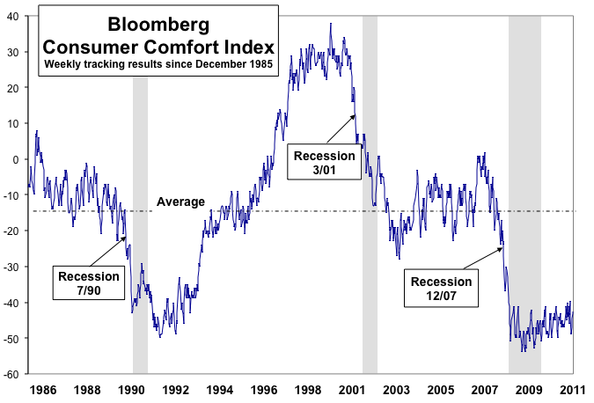

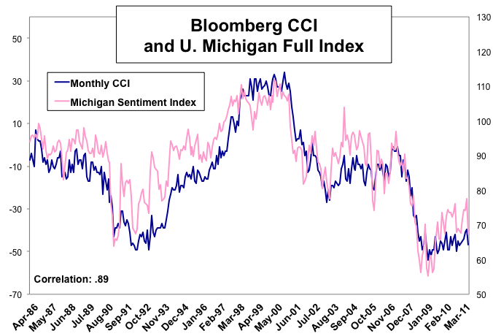

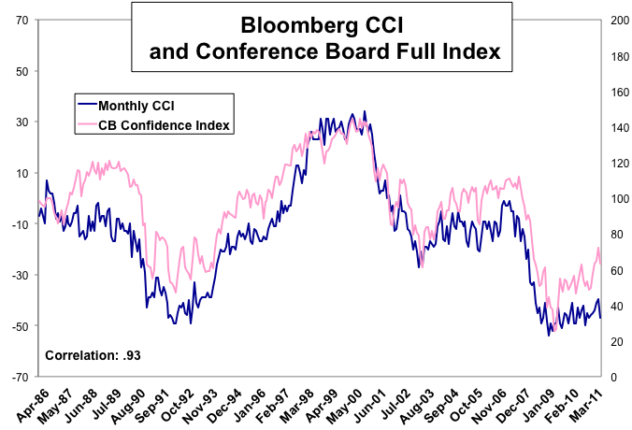
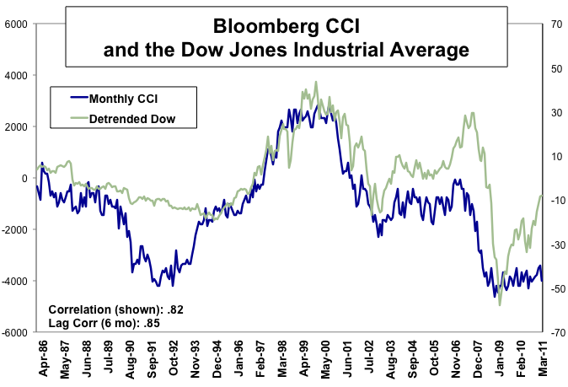

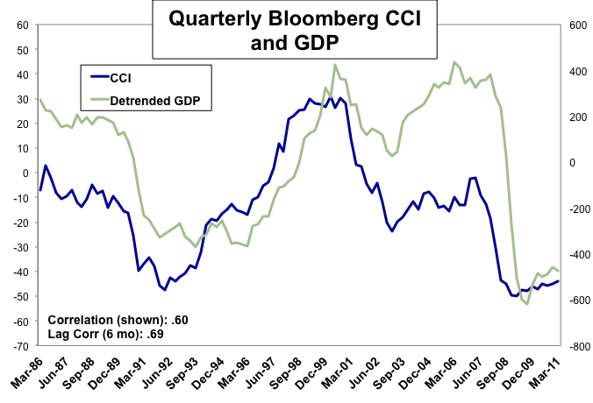

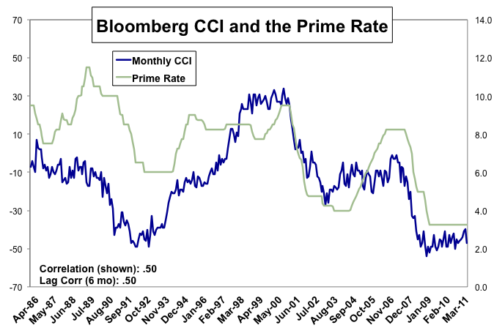

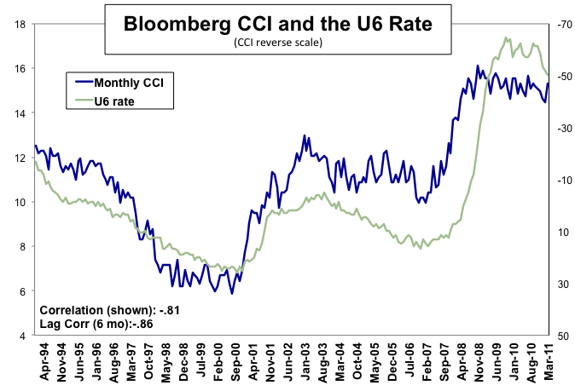
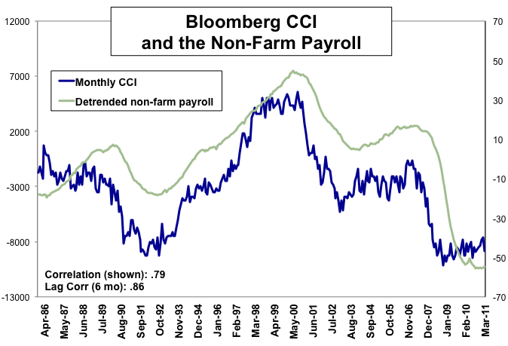

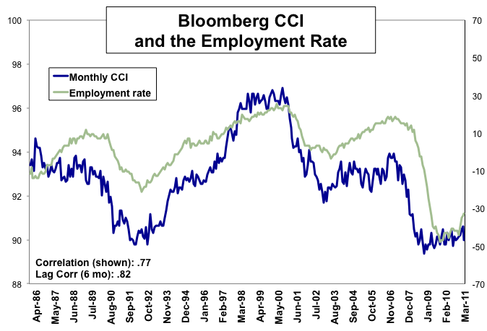’

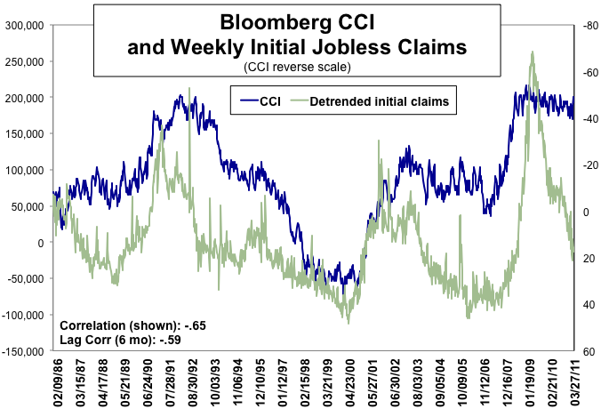

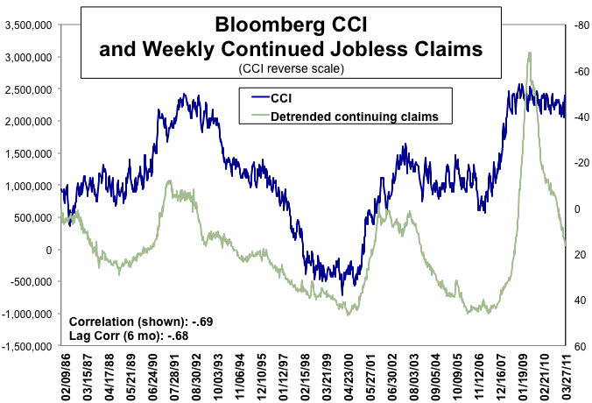

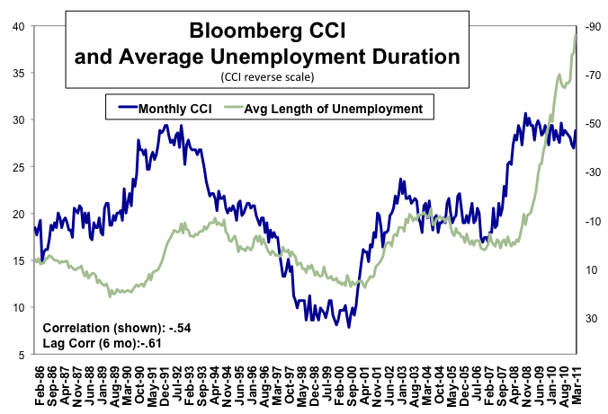

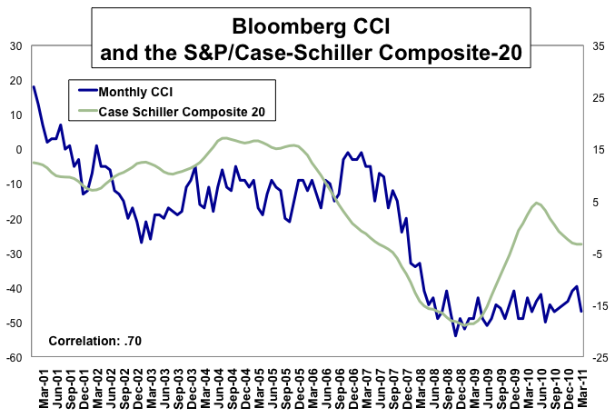

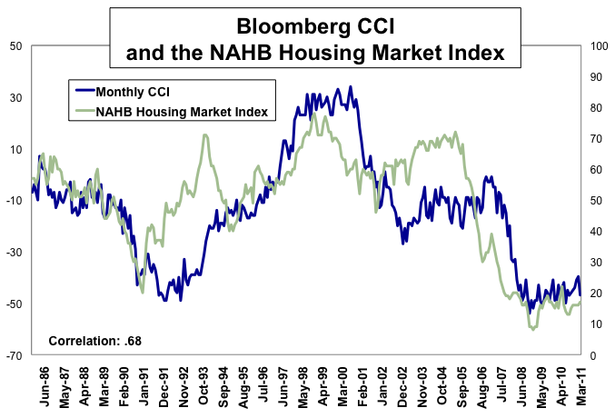

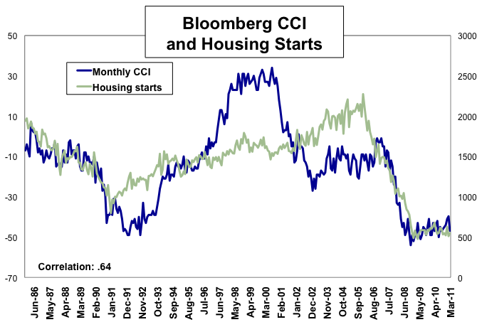

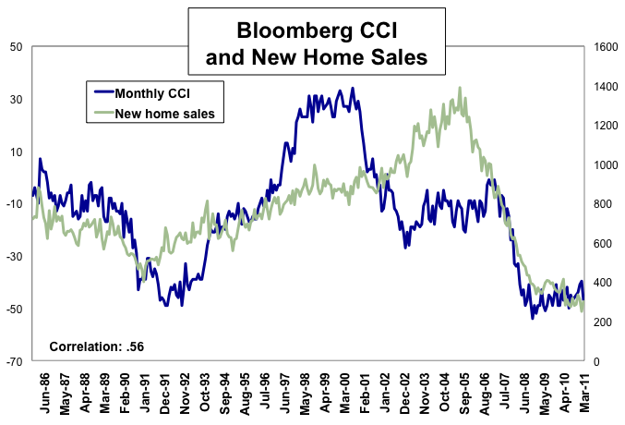

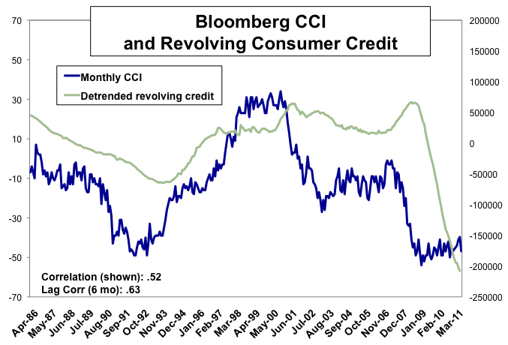

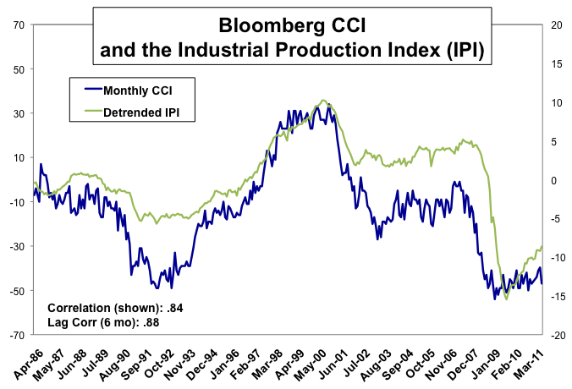

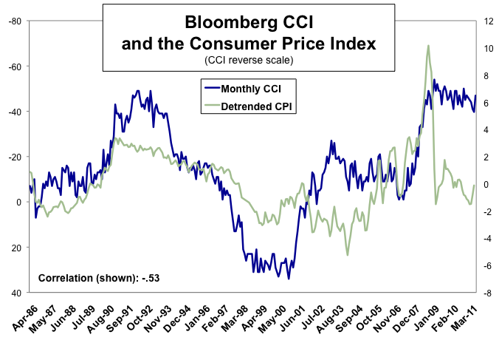

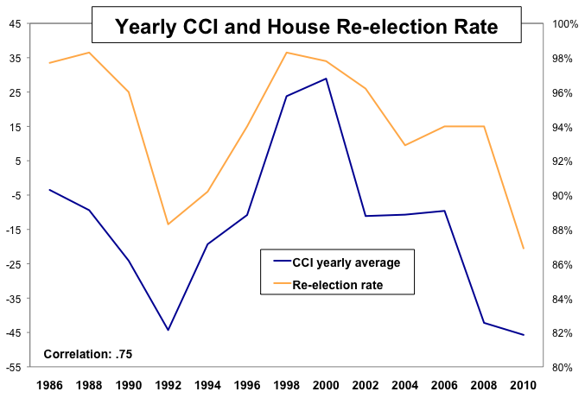

Formerly the ABC News, ABC News/Washington Post or ABC News/Money Magazine Consumer Comfort Index.
Note demographic data is available from June 1990 to present, n = 250.
Steiger’s z-test for comparing dependent correlations was utilized to compare the concurrent correlations to the lagged correlations.

