Bloomberg ® Consumer Comfort Index ™ Weekly Data Report

Embargoed for Release after 9:45 a.m. Thursday, March 19, 2015

Contact: Langer Research Associates, 212 456-2621
info@langerresearch.com

Data summary for 3/19/2015

CCI
This week 44.2
Last week 43.3
2015 high 47.3 Jan. 25
2015 low 42.7 Feb. 22
2015 average 44.5
2009 average 26.0 Worst full year
2000 average 64.4 Best full year
June 21, 2009 23 Record low (also three other dates in 2008-09)
Jan. 16, 2000 69 Record high
Average since 12/85 41.6

Individual measures:
Average Average
Positive ratings of: This week Last week 2015 ’85-’15
National economy 37% 37 38 34
Personal finances 57 55 57 55
Buying climate 38 38 39 36

Excel Not so
Full ratings of: -lent Good Good Poor
National economy 3% 34 41 22
Personal finances 8 49 28 15
Buying climate 3 35 44 18

Positive High Positive Low
Economy 80% Jan. 16, 2000 4% Feb. 8, 2009
Finances 70% latest Jan. 23, 2000 39% June 21 and 28, 2009
Buying climate 57% Jan. 16, 2000 18% latest Oct. 19, 2008

Economy’s direction:
Better Worse Same
3/15/15 30 27 43
2/15/15 35 26 38
1/18/15 36 29 34
12/14/14 32 30 38

Methodology: The Bloomberg Consumer Comfort Index is produced by Langer Research Associates. The index is reported in a four-week rolling average; this week’s results are based on a random national sample of 1,000 adults, reached by landline and cellular telephone, in the four weeks ending March 15, 2015. Results of the individual CCI gauges have a 3.5-point error margin. The expectations question was asked of 500 respondents March 4-15, 2015; that result has a 4.5-point error margin. Field work and tabulation by SSRS of Media, Pa.

As of May 1, 2014, the index is derived by averaging the positive responses to each index question. Results can range from 0 (all negative responses for all three measures) to 100 (all positive responses for all three measures). See details here. The survey began in December 1985.
03/15/15 This Last 4 Wks 3 Mo. 1 Yr. 12 Mo 12 Mo 12 Mo
Week Week Ago Ago Ago High Low Avg
----- ----- ----- ----- ----- ----- ----- -----
Group
--------
GENERAL POPULATION:
Overall Index 44.2 43.3 44.6 41.7 35.5 47.3 33.3 38.7
State of Economy 37.2 37.1 38.9 32.5 25.2 42.3 20.6 28.7
Personal Finances 57.1 54.8 56.6 54.1 50.3 60.7 48.6 53.1
Buying Climate 38.3 38.2 38.4 38.4 31.0 39.9 29.0 34.1
-------------------------------------------------------------------
OVERALL INDEX BY DEMOGRAPHIC GROUPS
Sex:
Men 45.4 43.7 49.0 45.1 38.9 52.4 34.2 41.8
Women 43.1 43.0 40.5 38.5 32.3 43.1 30.8 35.7
Age:
18 – 34 46.9 44.9 45.3 45.1 37.4 50.1 32.9 40.6
35 – 44 51.2 49.1 45.2 40.2 36.3 51.2 28.7 39.5
45 – 54 39.7 38.1 39.0 41.3 34.4 45.8 30.0 35.5
55 – 64 38.8 41.5 48.4 38.9 30.2 49.4 29.6 36.8
65+ 44.3 42.9 43.4 40.6 37.8 44.4 33.9 39.4
Income:
Under $15K 25.8 24.6 23.3 22.9 20.4 28.5 16.5 22.1
$15K To $24.9K 27.6 26.5 30.4 27.0 26.2 33.8 12.1 24.0
$25K To $39.9K 39.0 42.1 38.3 33.6 29.3 42.1 23.5 32.3
$40K To $49.9K 47.3 41.9 40.0 38.0 34.2 47.3 31.2 38.0
Under $50K 34.3 33.0 32.9 29.6 26.9 34.4 22.5 28.4
Over $50K 57.9 58.0 59.7 57.7 46.7 62.3 45.1 52.1
$50K To $74.9K 51.2 49.9 47.5 53.2 38.2 55.2 34.2 43.7
$75K To $99.9K 51.7 53.0 61.6 48.7 44.2 64.9 40.4 50.0
Over $100K 65.7 64.9 69.0 68.1 58.7 72.1 52.9 61.2
Region:
Northeast 39.1 42.5 44.8 44.4 30.9 46.3 28.1 38.2
Midwest 46.0 45.6 46.7 44.4 33.4 49.9 31.3 39.4
South 45.7 43.0 41.5 39.3 38.2 45.7 33.2 38.1
West 44.3 42.5 47.5 40.8 36.7 52.2 33.4 39.3
Race:
White 43.6 43.8 43.4 42.0 36.2 47.4 33.4 39.0
Black 40.6 42.0 47.3 38.7 30.8 49.3 25.9 35.8
Politics:
Republican 41.3 40.8 41.0 39.3 32.5 45.8 28.7 37.8
Democrat 50.4 51.3 52.2 48.7 40.7 52.2 37.0 44.0
Independent 41.6 39.2 42.0 38.3 33.7 47.3 29.8 36.1
Education:
< High School 30.4 27.7 26.0 20.7 27.5 36.4 13.3 22.6
High Sch. Grad. 35.8 35.5 39.1 37.4 29.5 41.1 27.4 33.4
College + 51.5 50.8 51.9 48.7 40.5 52.9 38.8 45.0
Home:
Own 47.9 47.3 49.1 46.3 37.3 53.2 36.5 42.5
Rent 38.2 37.3 38.2 33.4 32.7 38.4 24.7 32.3
Marital Status:
Single 44.7 43.6 40.1 42.8 36.8 45.5 30.2 37.9
Married 47.4 46.2 50.7 44.2 37.0 53.6 36.8 42.3
Sep/Wid/Div 34.9 35.1 34.0 32.0 30.6 35.5 24.2 29.1
Employ. Status:
Full-Time 47.3 47.0 51.9 47.8 41.2 55.5 36.5 44.2
Part-Time 44.8 46.1 43.5 40.2 31.6 48.7 28.9 37.7
Not Employed 39.9 37.5 36.6 35.3 31.1 39.9 28.3 32.7

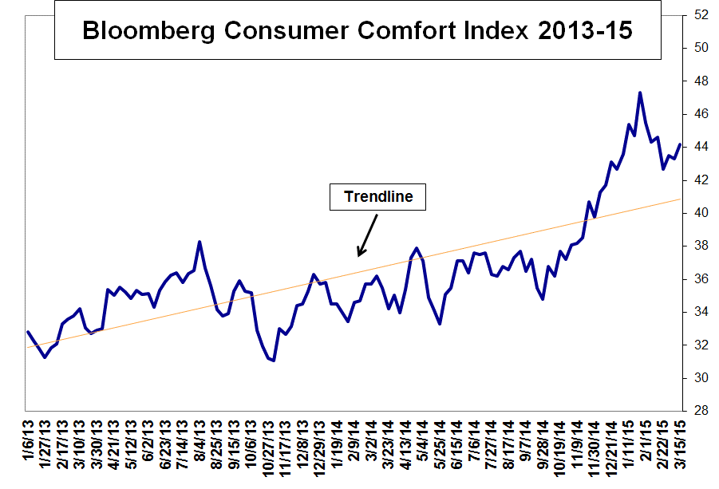

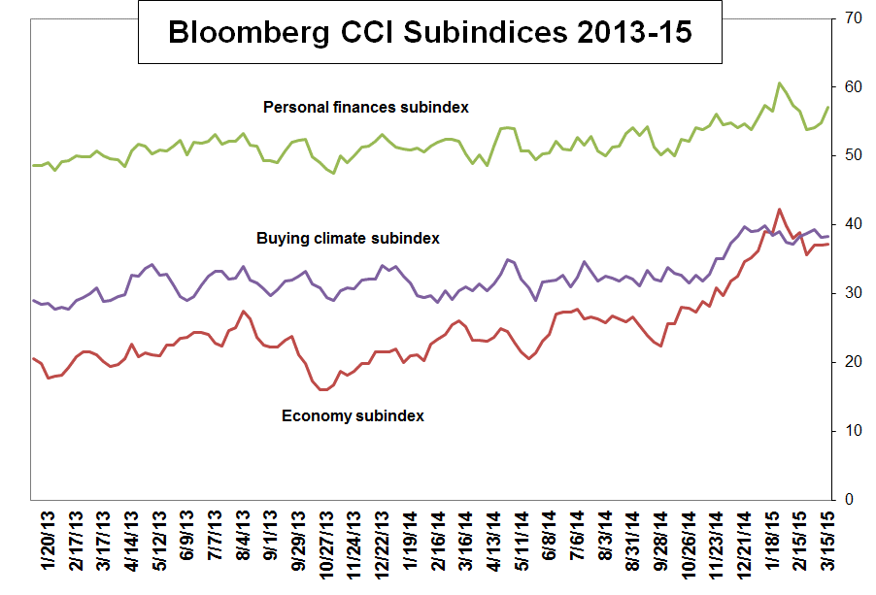

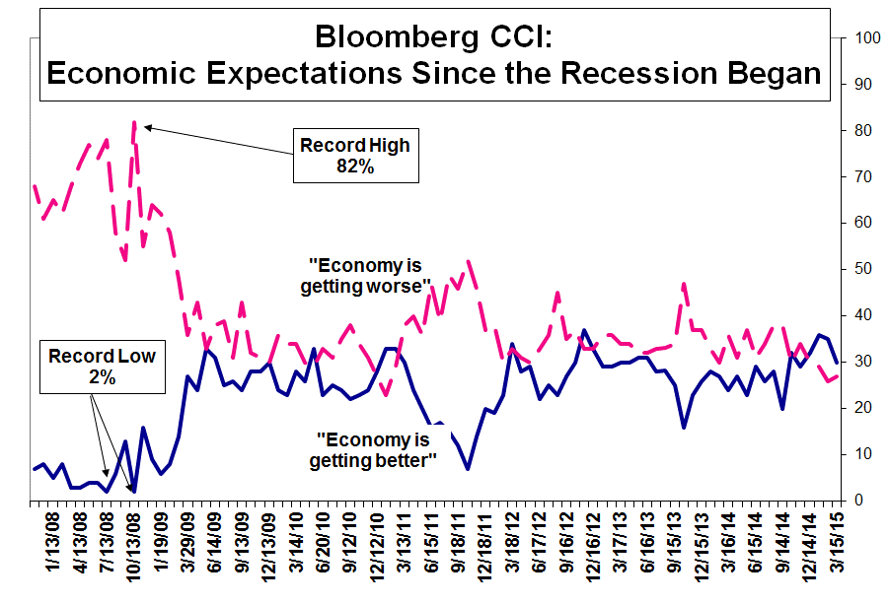

The Bloomberg Consumer Comfort Index is produced by Langer Research Associates LLC (Langer).CONSUMER COMFORT INDEX ™ is a trademark or service mark of Langer. BLOOMBERG ® is a trademark or service mark of Bloomberg Finance L.P. Bloomberg Finance L.P. and its affiliates (collectively, "Bloomberg") or Bloomberg's licensors own all proprietary right in such mark. Neither Langer nor Bloomberg guarantee the timeliness, accuracy or completeness of any data or information relating to the Bloomberg Consumer Comfort Index. Langer and Bloomberg make no warranty, express or implied, as to the Bloomberg Consumer Comfort Index or any data or values relating thereto or results to be obtained therefrom, and expressly disclaim all warranties of merchantability and fitness for a particular purpose with respect thereto. To the maximum extent allowed by law, Langer, Bloomberg, their licensors, and their respective employees, contractors, agents, suppliers and vendors shall have no liability or responsibility whatsoever for any injury or damages - whether direct, indirect, consequential, incidental, punitive or otherwise - arising in connection with the Bloomberg Consumer Comfort Index or any data or values relating thereto - whether arising from their negligence or otherwise. Nothing in the Bloomberg Consumer Comfort Index shall constitute or be construed as an offering of financial instruments or as investment advice or investment recommendations (i.e., recommendations as to whether or not to “buy,” “sell,” “hold” or to enter or not to enter into any other transaction involving any specific interest or interests) by Langer, Bloomberg or its affiliates or a recommendation as to an investment or other strategy by Langer, Bloomberg or its affiliates.

Click here for CCI details.
For subscription information: Langer Research Associates, info@langerresearch.com

