ABC NEWS/WASHINGTON POST POLL: Favorability #22
EMBARGOED FOR RELEASE AFTER 7 a.m. Thursday, April 5, 2012

Searching for the King of Tech?
In Popularity, Google Lays Claim

In the high-flying world of iconic technology brands, two – Google and Apple – tower at remarkable levels of public popularity in a new ABC News/Washington Post poll. But add in strength of sentiment and one of them claims the crown.

An almost unheard-of 82 percent of Americans express a favorable opinion of Google overall, the national survey finds – and a majority, 53 percent, express a “strongly” favorable opinion of the world’s leading search engine, itself an unusually high level of positive intensity.

Apple’s no slouch: Seventy-four percent see it favorably. But in addition to trailing Google by a relatively slim 8 percentage points overall, it lags by a wider 16 points in strong devotees.

Another leading tech brand is popular, albeit less so – 58 percent of Americans in this poll, produced for ABC by Langer Research Associates, express an overall favorable opinion of Facebook. But a fourth brand does less well: Only a third rate Twitter favorably, while about as many have a negative view of the creator of 140-character commentary.

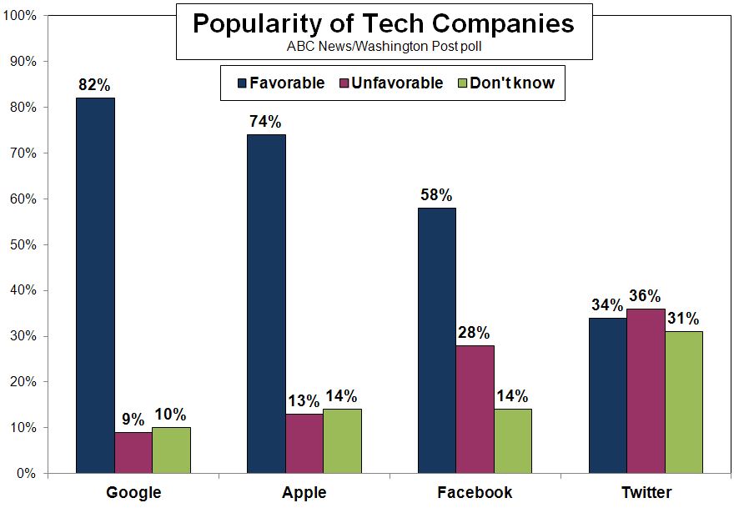
The time is ripe for this sort of assessment, given these companies’ envied positions in the marketplace. Google has followed up its vast lead in internet search and advertising with online and mobile technology software, among an array of other initiatives. Just yesterday the company provided a first look at the Google glasses concept, its “augmented reality” eyewear project.

Apple’s totemic products have made it the most valuable company in the world; it announced a dividend and stock buyback program last month as its shares soared past $600, with analysts pegging $1,000 as a possibility. Facebook, the world’s largest social networking site, is set to go public later this year in what is expected to be the largest internet initial public offering ever. And Twitter, the youngest of the four, has claimed its position as a combined social networking, messaging and marketing tool.

In addition to very broad popularity, Google and Apple share vast exposure. Just 10 percent of Americans haven’t formed a basic opinion of Google (rising to 29 percent of less tech-savvy seniors), and 14 percent have no opinion of Apple and Facebook alike. Twitter is less well known, with 31 percent unready to express an opinion of it, jumping to 51 percent of seniors.

GROUPS – Google and Apple are broadly popular across demographic groups, although, reflecting their emphasis on design and innovation, tend to particularly do well among the young, highly educated and affluent.

Favorability of both brands peaks among people with household incomes of $100,000 or more; in this group a near-unanimous 93 and 91 percent express favorable opinions of Google and Apple, respectively. Among those under age 30, Google maintains 92 percent favorability, Apple, 81 percent. And both are more popular among college graduates (88 and 84 percent) than their counterparts (a still-impressive 79 and 70 percent).

The intensity gap closes among better -off adults and widens among under-30s. Google is viewed “strongly” favorably by 66 percent of the more affluent, Apple by 60 percent, not a statistically significant difference. Among young adults, though, this widens to a 34-point gap in Google’s favor.

Facebook’s popularity also peaks among young adults, at 76 percent. It’s got a particularly sharp drop-off among senior citizens; just 34 percent of adults age 65 and over see it favorably, while about as many seniors, 33 percent, view the company unfavorably. It also shows an ideological gap: Seventy percent of liberals have a favorable opinion of Facebook, compared with 55 percent of moderates and 54 percent of conservatives.

There’s also a 10-point gender gap in views of Facebook, with the site seen favorably by 63 percent of women vs. 53 percent of men. Twitter’s got a similar gap, 11 points more popular among women than men, though it’s rated lower than the others among both sexes, at 39 and 28 percent, respectively.

Even among young adults, Twitter is seen favorably by just 42 percent, and unfavorably by equally as many, 43 percent. Among seniors its positive rating drops to 18 percent; for 30 percent in this group, tweeting, apparently, is for the birds.

METHODOLOGY – This ABC News/Washington Post poll was conducted by landline and cell phone March 28-April 1, 2012, among a random national sample of 1,007 adults. Results have a margin of sampling error of 3.5 points. The survey was produced for ABC News by Langer Research Associates of New York, N.Y., with sampling, data collection and tabulation by SSRS/Social Science Research Solutions of Media, Pa.

Analysis by Damla Ergun.

ABC News polls can be found at ABCNEWS.com at http://abcnews.com/pollingunit.

Media contacts: David Ford, (212) 456-7243, and Julie Townsend, (212) 456-4934.

Full results follow.

1. Overall, do you have a favorable or unfavorable impression of (ITEM)? Do you feel that way strongly or somewhat? (ITEMS SCRAMBLED)

4/1/12 – Summary Table

------- Favorable ------- ------ Unfavorable ------ No
NET Strongly Somewhat NET Somewhat Strongly opinion
a. Google 82 53 29 9 5 4 10
b. Apple 74 37 37 13 8 4 14
c. Facebook 58 23 35 28 15 13 14
d. Twitter 34 8 26 36 22 14 31

*** END ***

