ABC NEWS/WASHINGTON POST POLL: Election Tracking No. 8
EMBARGOED FOR RELEASE AFTER 5 p.m. Monday, Oct. 29, 2012

Edge on the Middle Class
Helps Obama Counterpunch

With the election a week away Mitt Romney faces persistent skepticism about his commitment to the middle class, a vulnerability for the Republican challenger that’s keeping the race locked tight – a precise dead heat in the latest ABC News/Washington Post tracking poll, 49-49 percent.

Barack Obama, for his part, inched to a bare majority in job approval in the latest four-night survey, benefitting from a gradual improvement in economic attitudes – still weak, but trending up. Notably, it’s his first time over 50 percent approval among likely voters in ABC/Post polls since July, just in time to counter what had been underlying momentum for Romney last week.

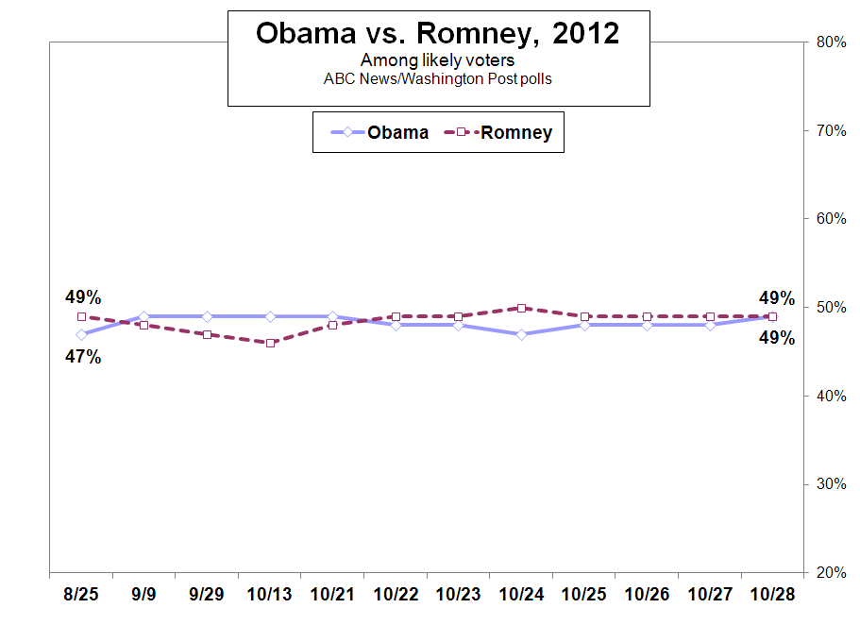

In one of Obama’s key assets, a broad 66 percent of likely voters continue to say he does more to favor the middle class than the wealthy, a measure that’s held steady even as Romney gained on a range of other attitudes. Just 14 percent in this poll, produced for ABC by Langer Research Associates, think Obama favors the wealthy.

Romney continues to struggle on the same question: Just 34 percent think that, as president, he’d favor the middle class; virtually the same as it’s been in ABC/Post polls since midsummer. Fifty-three percent think he’d favor the wealthy – enough for trouble.

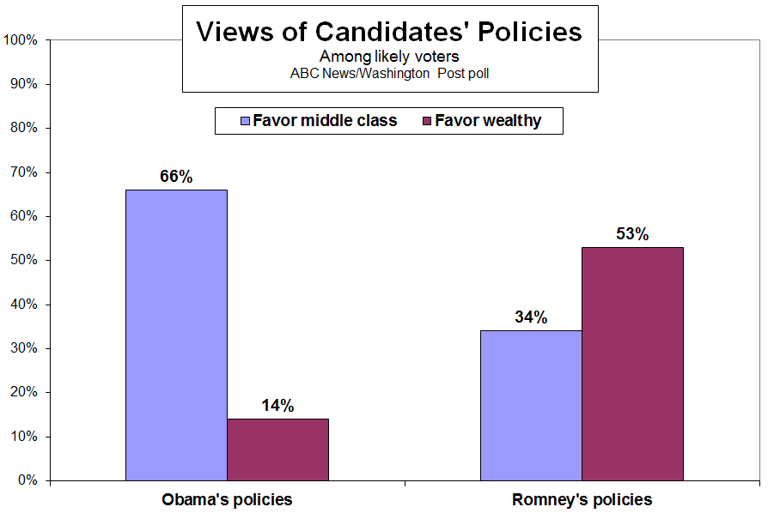

Among people who don’t think Romney would favor the wealthy, nearly all support him – by a vast 92-6 percent. But among the 53 percent who do think he’d do more for the wealthy than the middle class, that flips to nearly as broad a margin in Obama’s favor, 87-10 percent.

BETTER? – Romney’s response on the middle class has been to underscore the shortfall in prosperity that’s made Obama vulnerable in the first place. Just 22 percent in this poll say they’ve gotten better off under his presidency, vs. 33 percent worse off. The rest say they’re in about the same shape financially as when Obama took office.

But the trend in these sentiments also is keeping Obama in the game. The “better off” number has advanced from a mere 8 percent among all Americans in July 2009 and from 13 percent a year ago. The “worse off” number, in the past year, has been essentially unchanged.

Obama, naturally, has a huge lead among “better off” likely voters, 82-17 percent, as does Romney among the larger number who say they’re worse off, 89-10 percent. (It’s worth noting that political predispositions color these financial self-assessments.) The tougher battle for Romney is among people who say they’re in the same shape financially as when Obama took office; they currently split in Obama’s favor, 61-35 percent.

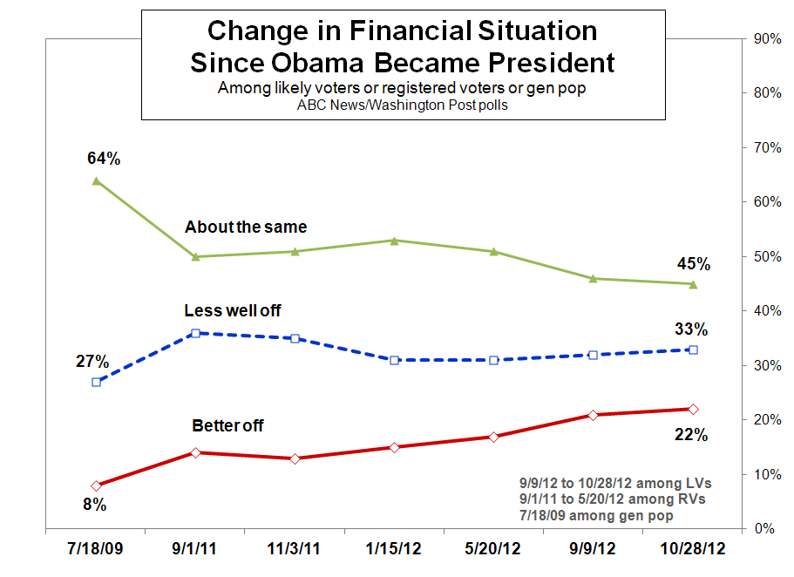

These dynamics appear to have helped Obama stem Romney’s advance on other basic economic views after the final debate last week. Through September and mid-October the two were in a virtual dead heat in trust to handle the economy. By the middle of last week Romney’d taken a 9-point lead on this key question. But it’s reverted since – now Romney +2, essentially tied again.

On economic empathy, similarly, Obama is back to a marginal advantage, 50-44 percent vs. Romney in “understanding the economic problems people in this country are having.” That, too, had tightened last week, to a non-significant +2 for Obama, the closest of the campaign.

The give-and-take on these measures illustrate the reasons the race is so close: Discontent with the economy, but somewhat less pessimism about its impacts; soft approval ratings for the president, yet still at the halfway mark; and mixed views on who’s better suited both to handle the economy, and to understand the damage it’s done to average Americans.

CONTACT and GROUPS – If it stays this close, a dead-even race is one that’s decided by turnout, and there the ground games come into play. The latest data show Romney still keeping pace with Obama in voter contacts overall – but Obama moving back to an edge in efficiency, that is, in contacting people who actually support him, in order to encourage their turnout.

Nationally, 26 percent of likely voters say they’ve personally been contacted by a representative of Obama’s campaign, 24 percent by Romney’s. In the 10 states designated as battlegrounds by the ABC News Political Unit, more, 45 percent, report being contacted by Obama, 39 percent by Romney.

In efficiency, Obama has regained a lead, especially in the battleground states. There, among those contacted by the Obama campaign, 66 percent say they’re in fact Obama supporters. Among those contacted by Romney’s campaign, fewer support him, 51 percent.

Trends among groups, meanwhile, show continued remarkable polarization. Ninety-one percent of Democrats support Obama, at the high end for the party’s past presidential candidates. Romney, for his part, is at 94 percent among Republicans, a new high of the campaign.

Independents are customarily a more changeable group, as they’re less anchored by partisanship. They now divide 53-43 percent in Romney’s favor. Independents are a more GOP-leaning group now than in 2008; how far they lean could make the difference next week.

METHODOLOGY – This ABC News/Washington Post poll was conducted by telephone Oct. 25-28, 2012, among a random national sample of 1,259 likely voters, including landline and cell-phone-only respondents. Results have a margin of sampling error of 3.5 points, including design effect. The survey was produced for ABC News by Langer Research Associates of New York, N.Y., with sampling, data collection and tabulation by Abt-SRBI of New York, N.Y.

Partisan divisions in this survey, Democrats-Republicans-independents, are 35-28-34 percent among likely voters. Partisan divisions in the 2008 exit poll were 39-32-29 percent. “Battleground states” as designated by the ABC News Political Unit are Colorado, Florida, Iowa, Nevada, New Hampshire, North Carolina, Ohio, Pennsylvania, Virginia and Wisconsin.

Analysis by Gary Langer.

ABC News polls can be found at ABCNEWS.com at http://abcnews.com/pollingunit.

Media contacts: David Ford, (212) 456-7243, and Julie Townsend, (212) 456-4934.

Full results follow.

*= less than 0.5 percent

1. (ASKED OF REGISTERED VOTERS) How closely are you following the 2012 presidential race: very closely, somewhat closely, not so closely, or not closely at all?

---- Closely ----- ---- Not closely ----- No
NET Very Smwt NET Not so At all opinion
10/28/12 LV 99 69 30 1 1 * *
10/27/12 LV 99 68 31 1 1 * *
10/26/12 LV 99 66 33 1 1 * 0
10/25/12 LV 95 62 33 5 3 2 *
10/24/12 LV 94 63 32 5 3 2 *
10/23/12 LV 93 63 31 6 4 2 *
10/22/12 LV 92 64 28 8 5 3 *
10/21/12 LV 92 64 28 8 5 3 *
10/13/12 LV 93 60 33 6 4 2 *
9/29/12 LV 92 54 38 8 6 2 0
9/9/12 LV 87 51 36 13 8 5 1
5/20/12 RV 82 38 44 18 9 8 *
2/4/12* RV 79 37 43 20 12 8 *
1/15/12 RV 76 33 43 24 14 10 *
*2/4/12 and previous not “too” closely
Call for full trend.

2. (ASKED OF REGISTERED VOTERS) I'd like you to rate the chances that you will vote in the presidential election in November: Are you absolutely certain to vote, will you probably vote, are the chances 50-50, or less than that?

Don't think Already
Certain Probably Chances Less than will vote voted No
to vote vote 50/50 that (vol.) (vol.) op.
10/28/12 RV 77 5 4 2 1 11 *
10/27/12 RV 79 5 5 2 * 9 *
10/26/12 RV 79 6 5 2 * 8 *
10/25/12 RV 79 6 6 2 1 6 *
10/24/12 RV 79 7 6 2 1 6 *
10/23/12 RV 80 6 6 2 1 5 *
10/22/12 RV 82 5 6 2 1 4 *
10/21/12 RV 84 6 4 2 * 4 *
10/13/12 RV 85 7 4 1 1 1 1
9/29/12 RV 84 7 7 2 * 0 *
9/9/12 RV 83 7 6 4 * NA 0
8/25/12 RV 81 8 6 3 1 *
7/8/12 RV 81 9 8 2 * " *
Call for full trend.

2x. (IF CERTAIN TO VOTE) Do you think you'll (vote in person at your polling place on Election Day), or (vote before Election Day by early voting or mail-in ballot)?

Vote Early voting/ Already
in person mail-in ballot voted (vol.) No opinion
10/28/12 LV 60 22 15 2
10/27/12 LV 62 24 12 2
10/26/12 LV 62 25 11 2
10/25/12 LV 61 29 8 1
10/24/12 LV 62 29 8 1
10/23/12 LV 62 28 7 2
10/22/12 LV 64 27 6 2
10/21/12 LV 66 27 5 2
10/13/12 LV 67 30 2 1
Call for full trend.

3. (IF CERTAIN TO VOTE) If the presidential election were being held today and the candidates were (Barack Obama and Joe Biden, the Democrats) and (Mitt Romney and Paul Ryan, the Republicans), for whom would you vote? Which candidates are you leaning toward, (Barack Obama and Joe Biden, the Democrats) or (Mitt Romney and Paul Ryan, the Republicans)? (ASKED IF ALREADY VOTED) For whom did you vote?

NET LEANED VOTE PREFERENCE - among likely voters

Other Neither No
Obama Romney (vol.) (vol.) opinion
10/28/12 LV 49 49 1 1 1
10/27/12 LV 48 49 1 1 1
10/26/12 LV 48 49 1 1 1
10/25/12 LV 48 49 1 1 1
10/24/12 LV 47 50 1 1 1
10/23/12 LV 48 49 * 1 1
10/22/12 LV 48 49 * 2 1
10/21/12 LV 49 48 * 2 1
10/13/12 LV 49 46 1 1 2
9/29/12 LV 49 47 * 2 1
9/9/12 LV 49 48 * 1 2
8/25/12 LV 47 49 1 1 1
7/8/12* LV 50 47 * 2 2
*7/18/12: VPs not included

6. (IF SUPPORT/VOTED OBAMA OR ROMNEY) Would you say you are very enthusiastic about supporting (Obama/Romney), somewhat enthusiastic, not so enthusiastic, or not enthusiastic at all?

---- Enthusiastic --- --- Not enthusiastic ---- No
NET Very Somewhat NET Not so Not at all opinion
Obama:
10/28/12 LV 95 66 30 4 2 1 1
10/27/12 LV 95 64 31 4 3 1 1
10/26/12 LV 94 61 33 4 3 1 1
10/25/12 LV 94 59 35 5 3 2 1
10/24/12 LV 96 60 35 4 3 1 *
10/23/12 LV 95 60 35 4 3 1 *
10/22/12 LV 96 62 34 4 3 1 *
10/21/12 LV 96 64 32 4 3 1 *
10/13/12 LV 95 60 35 4 4 1 *
9/29/12 RV 91 51 40 9 7 2 0
9/9/12 RV 93 56 38 7 3 3 0
8/25/12 RV 88 48 39 11 7 4 1
7/8/12 RV 91 51 40 8 5 3 1
5/20/12 RV 93 51 41 7 4 4 0

Romney:
10/28/12 LV 94 61 33 5 4 1 *
10/27/12 LV 95 59 36 5 3 2 *
10/26/12 LV 93 59 35 6 5 2 *
10/25/12 LV 93 58 35 7 5 2 1
10/24/12 LV 93 60 33 7 5 2 1
10/23/12 LV 93 62 31 6 5 1 1
10/22/12 LV 93 62 32 6 4 2 1
10/21/12 LV 93 58 35 6 5 1 1
10/13/12 LV 93 62 31 7 4 2 1
9/29/12 RV 87 48 39 13 6 7 *
9/9/12 RV 87 46 40 13 7 6 1
8/25/12 RV 83 42 41 17 12 4 *
7/8/12 RV 85 38 47 15 11 4 *
5/20/12 RV 75 26 48 25 15 9 1
Call for full trend.

6x. (ASKED OF LIKELY VOTERS) Have you voted for president in any year before this 2012 election, or is this the first year you’ll be voting for president?

Voted before First time No opinion
10/28/12 LV 96 4 0
10/27/12 LV 93 7 0
10/26/12 LV 92 8 0
Call for full trend.

7. (ASKED OF REGISTERED VOTERS) Do you approve or disapprove of the way Obama is handling his job as president? Do you approve/disapprove strongly or somewhat?

-------- Approve -------- ------- Disapprove ------ No
NET Strongly Somewhat NET Somewhat Strongly opinion
10/28/12 LV 51 31 20 47 9 39 1
10/27/12 LV 50 30 20 48 8 40 2
10/26/12 LV 50 30 19 48 8 41 2
10/25/12 LV 49 30 19 49 8 41 2
10/24/12 LV 49 30 18 50 9 41 1
10/23/12 LV 50 30 19 49 9 40 2
10/22/12 LV 49 31 18 49 9 40 2
10/21/12 LV 50 31 19 48 8 40 2
10/13/12 LV 50 32 18 48 9 40 2
9/29/12 LV 48 27 21 51 10 41 1
9/9/12 LV 49 30 19 50 9 41 1
8/25/12 LV 48 27 21 50 11 39 2
7/8/12 LV 51 29 23 46 7 40 2
5/20/12 RV 48 29 20 49 11 38 3
4/8/12 RV 51 32 19 45 10 36 4
3/10/12 RV 46 29 18 51 10 40 3
2/4/12 RV 50 28 21 47 10 38 3
1/15/12 RV 48 26 22 48 10 38 4
Call for full trend.

12a. (ASKED OF LIKELY VOTERS) Regardless of who you support, which candidate do you trust to do a better job handling the economy - (Obama) or (Romney)?

Both Neither No
Obama Romney (vol.) (vol.) opinion
10/28/12 LV 47 49 1 2 2
10/27/12 LV 45 50 1 3 2
10/26/12 LV 44 51 1 3 2
10/25/12 LV 44 51 1 3 1
10/24/12 LV 43 52 1 3 2
10/23/12 LV 44 50 1 3 2
10/22/12 LV 45 50 1 2 2
10/21/12 LV 46 48 1 3 2
10/13/12 LV 48 47 * 2 3
9/29/12 RV 47 47 * 4 2
9/9/12 RV 47 45 * 3 4
8/25/12 RV 43 50 * 4 3
7/8/12 RV 45 48 1 3 3
5/20/12 RV 47 47 * 3 3
4/8/12 RV 44 48 1 4 3
2/4/12 RV 44 50 1 3 2

13a. (ASKED OF LIKELY VOTERS) Regardless of who you may support, who do you think better understands the economic problems people in this country are having - (Obama) or (Romney)?

Both Neither No
Obama Romney (vol.) (vol.) opinion
10/28/12 LV 50 44 2 3 1
10/27/12 LV 49 44 2 4 1
10/26/12 LV 48 45 2 4 1
10/25/12 LV 49 47 1 3 1
10/24/12 LV 48 46 2 3 1
10/23/12 LV 50 45 2 2 1
10/22/12 LV 51 44 2 2 1
10/21/12 LV 51 44 2 3 1
10/13/12 LV 51 42 2 4 1
9/29/12 RV 52 39 2 6 1
9/9/12 RV 50 40 3 4 3
8/25/12 RV 47 40 1 9 2
7/8/12 RV 51 40 2 5 2
5/20/12 RV 48 40 2 8 2
4/8/12 RV 49 38 2 8 2
2/4/12 RV 52 37 2 7 2

14. (ASKED OF LIKELY VOTERS) Do you think Obama does more to favor the (middle class) or more to favor the (wealthy)?

Favor Favor Treat No
middle class wealthy equally (vol.) opinion
10/28/12 LV 66 14 6 14
10/21/12 LV 66 15 6 13
10/13/12 LV 68 16 4 11
9/29/12 LV 66 16 6 12
8/25/12 LV 62 20 6 11

15. (ASKED OF LIKELY VOTERS) As president do you think Romney would do more to favor the (middle class) or more to favor the (wealthy)?

Favor Favor Treat No
middle class wealthy equally (vol.) opinion
10/28/12 LV 34 53 8 5
10/21/12 LV 33 54 9 5
10/13/12 LV 33 57 6 4
9/29/12 LV 37 55 4 4
8/25/12 LV 32 57 6 5

22. (ASKED OF LIKELY VOTERS) Would you say you, yourself, are better off financially than you were when Obama became president, not as well off, or in about the same shape financially?

Better off Not as well off About the same No opinion
10/28/12 LV 22 33 45 1
9/9/12 LV 21 32 46 *
5/20/12 RV 17 31 51 1
1/15/12 RV 15 31 53 1
11/3/11 RV 13 35 51 1
9/1/11 RV 14 36 50 1
7/18/09 8 27 64 *

18. (ASKED OF LIKELY VOTERS) Have you personally been contacted by a representative of the [CANDIDATE] campaign, either by phone, in-person, or online asking you for your support, or not?

10/28/12 - Summary Table (among likely voters)

Yes No No opinion
a. Obama 26 72 2
b. Romney 24 74 2

Trend:

a. Obama
Yes No No opinion
10/28/12 LV 26 72 2
10/27/12 LV 23 75 2
10/26/12 LV 23 75 2
10/25/12 LV 22 76 2
10/13/12 LV 27 71 2
9/29/12 RV 23 76 1
8/25/12 RV 20 79 1

b. Romney
Yes No No opinion
10/28/12 LV 24 74 2
10/27/12 LV 23 75 2
10/26/12 LV 23 75 2
10/25/12 LV 23 75 2
10/13/12 LV 22 75 3
9/29/12 RV 20 79 1
8/25/12 RV 13 86 *

18o. (IF CONTACTED BY OBAMA CAMPAIGN) When was the last time you were contacted, within the last week, within the last month or longer ago than that?

Within last Within last Longer No
week month ago opinion
10/28/12 LV 63 25 9 3
10/27/12 LV 62 28 8 2
10/26/12 LV 62 27 9 2
10/25/12 LV 61 29 6 4
10/13/12 LV 54 37 9 *
9/29/12 RV 53 34 10 3

18/18o NET:
---------------------- Yes ----------------------- Not No
NET Last week Last month Longer Don't know contacted op.
10/28/12 LV 26 16 7 2 1 72 2
10/27/12 LV 23 14 6 2 1 75 2
10/26/12 LV 23 14 6 2 1 75 2
10/25/12 LV 22 13 6 1 1 76 2
10/13/12 LV 27 15 10 2 * 71 2
9/29/12 RV 23 12 8 2 NA 76 1

18r. (IF CONTACTED BY ROMNEY CAMPAIGN) When was the last time you were contacted, within the last week, within the last month or longer ago than that?

Within last Within last Longer No
week month ago opinion
10/28/12 LV 64 26 7 4
10/27/12 LV 63 25 8 4
10/26/12 LV 58 32 8 2
10/25/12 LV 57 33 8 2
10/13/12 LV 57 35 7 1
9/29/12 RV 55 34 9 1

18/18r NET:
---------------------- Yes ----------------------- Not No
NET Last week Last month Longer Don't know contacted op.
10/28/12 LV 24 15 6 2 1 74 2
10/27/12 LV 23 14 6 2 1 75 2
10/26/12 LV 23 13 7 2 * 75 2
10/25/12 LV 23 13 8 2 * 75 2
10/13/12 LV 22 13 8 2 * 75 3
9/29/12 RV 20 11 7 2 NA 79 1

*** END ***

